**Introduction**

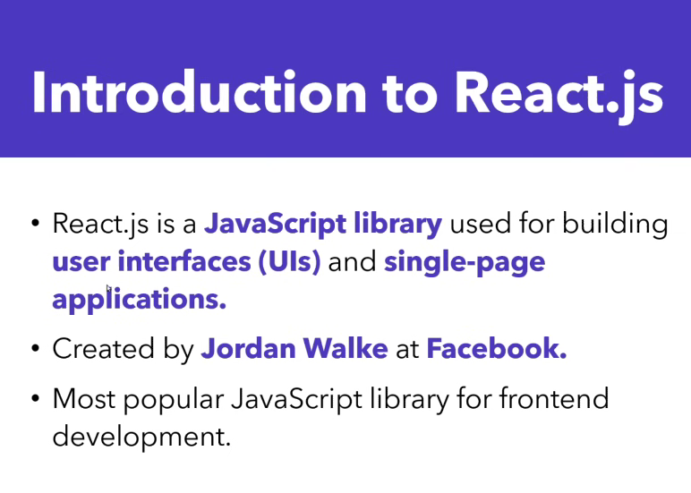

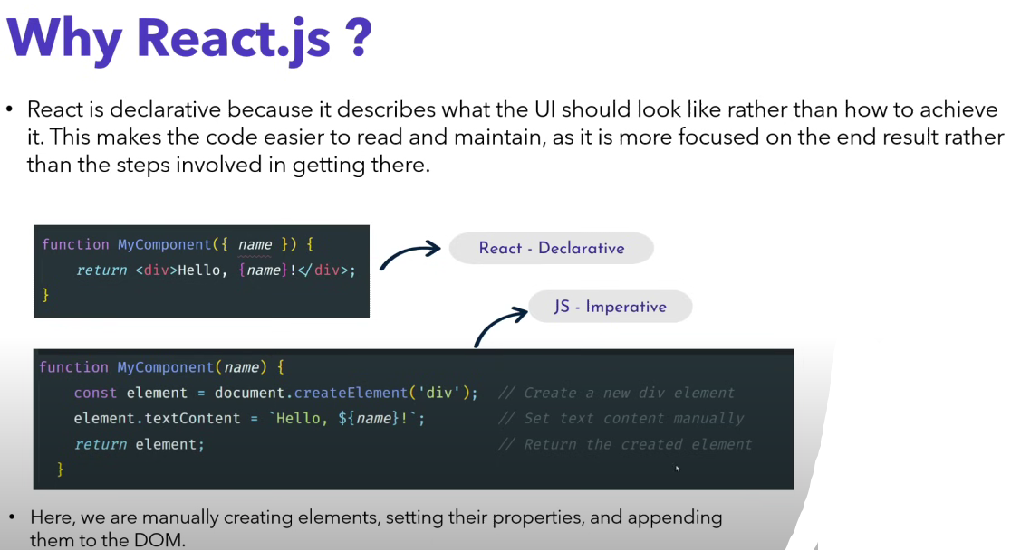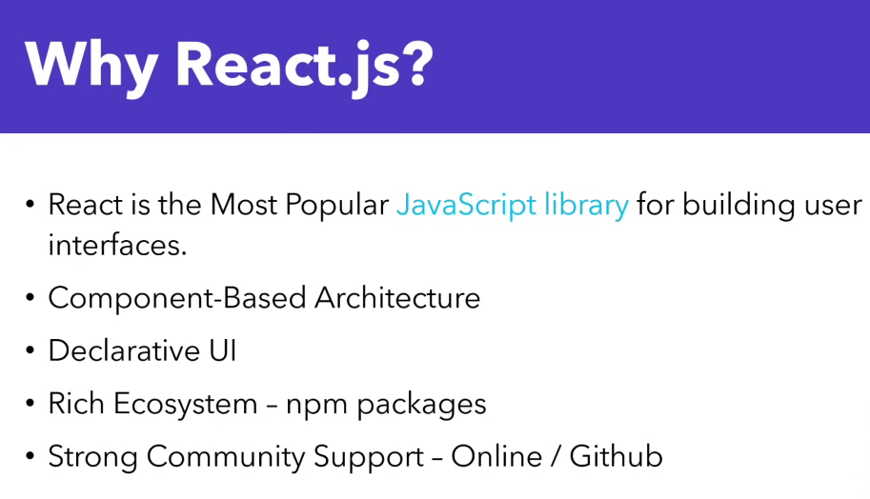

**Installation**

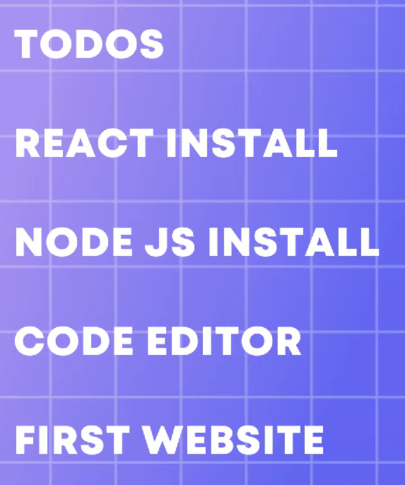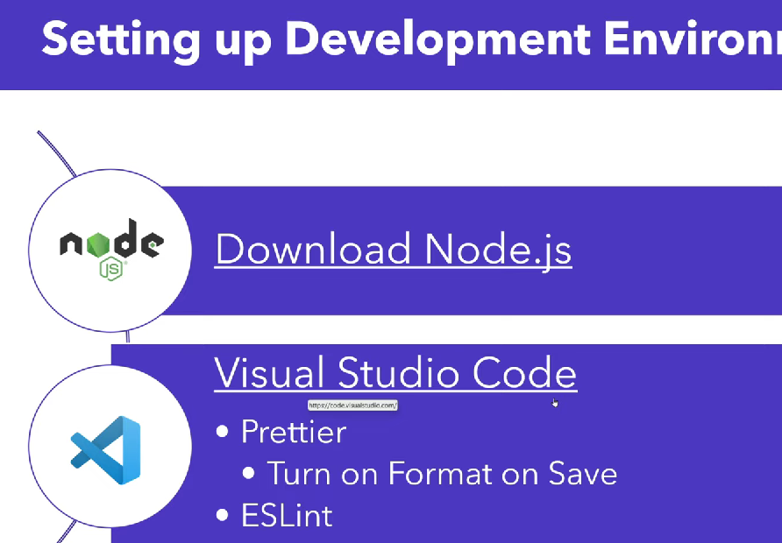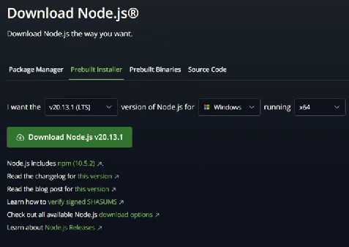

**–Node Js**

Node allows developers to write JavaScript code that runs directly in a computer process itself instead of in a browser.

Node.js is a cross-platform, open-source JavaScript runtime environment that can run on Windows, Linux, Unix, macOS, and more. Node.js runs on the V8 JavaScript engine, and executes JavaScript code outside a web browser. Node.js lets developers use JavaScript to write command line tools and for server-side scripting.

**Bydefault npm installed with node**

**–Bun - package manager**

Develop, test, run, and bundle JavaScript & TypeScript projects—all with Bun.   
  
Bun is an all-in-one JavaScript runtime & toolkit designed for speed, complete with a bundler, test runner, and **Node.js-compatible package manager.**

<https://bun.sh/>



**npm i -g bun**

**Why we use bun 👇**

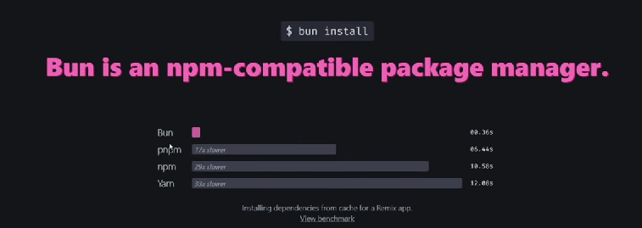

Bun is fast because it uses the JavaScriptCore engine, while Node. js uses the JavaScript V8 engine. The former has been optimised for faster startup time. If you want to get things done faster, you should consider replacing Node.

**–Vite Js**

**After that install Vite Js**

<https://vitejs.dev/guide/>

Vite JS is majorly used to set up a development environment for various frameworks like React and Vue.

**bun create vite**

Then follow next steps to create react app

Run app

bun run dev

**Successfully created react app 👇**

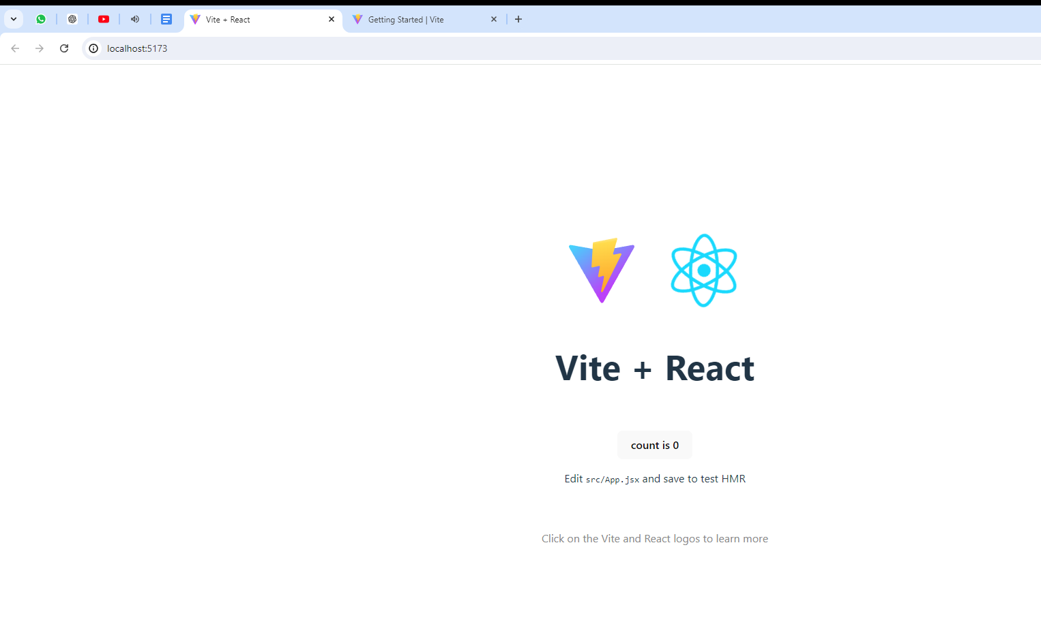

**Useful commands**

For install latest react version 19 remove dependencies 18 something

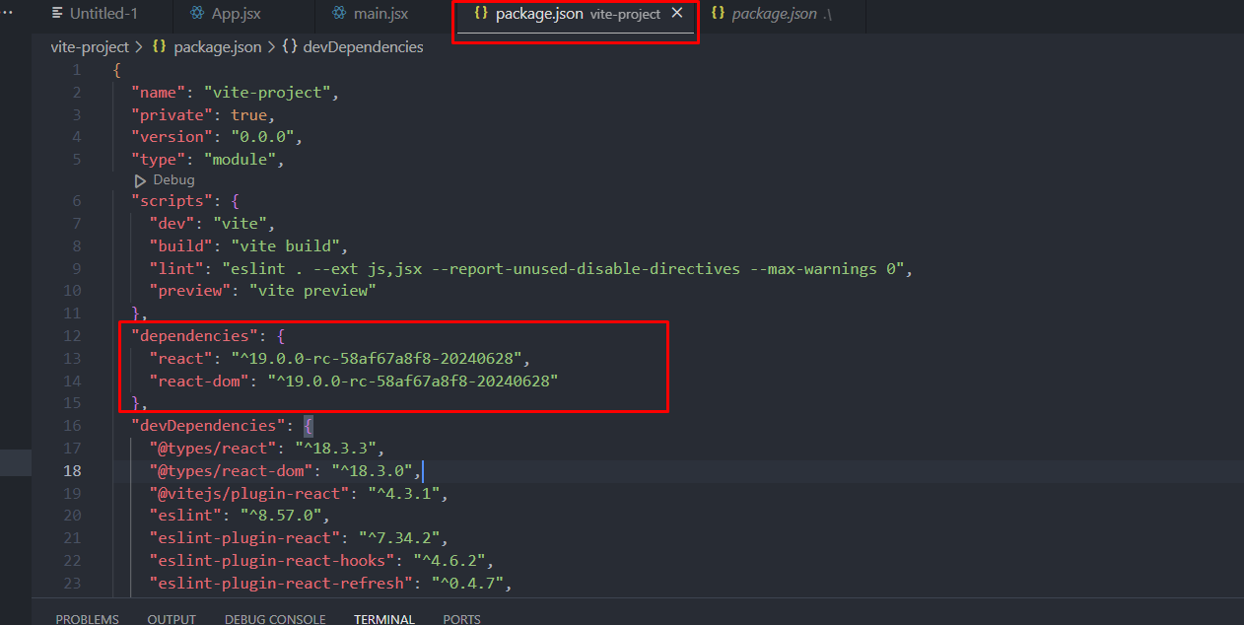

Then run following command 👇

bun install react@rc

bun i react-dom@rc

**Prerequisites**

Before learning ReactJs, It is essential to understand **HTML, CSS, and JavaScript.**

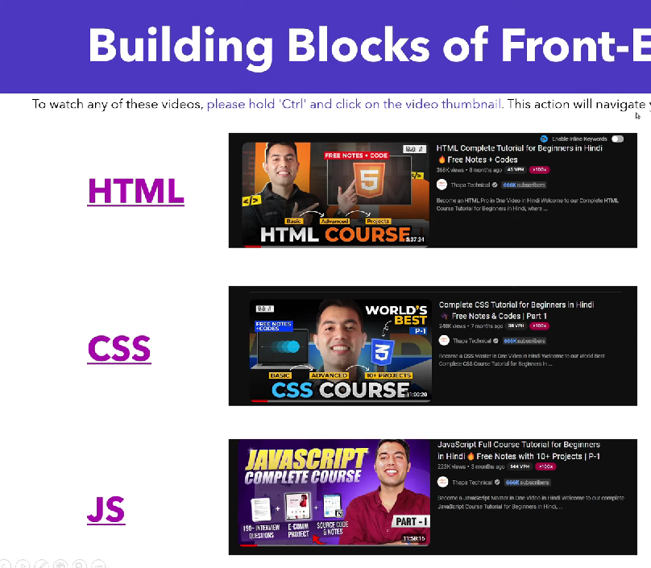

**Folder Structure**

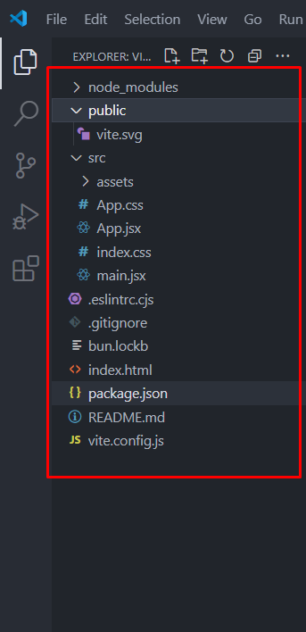

**– 1 Node modules**

The node_modules directory is where all the dependencies packages are stored that are used to build and run your react project.

**– 2 Public**

This folder contains all the static files like images, videos and font etc..

**– 3 Src**

This folder contains all the source files

–React Components in .jsx files

–Javascript

–CSS

**– 4 eslintrc.cjs**

In a React project, the . eslintrc. cjs file is a configuration file used to set the rules for ESLint. ESLint is a popular JavaScript code linter that helps developers identify issues within their code, maintaining code quality and consistency.

**– 5 gitignore**

The .gitignore file is used to specify which files and directories Git should ignore in a project. This is useful for excluding temporary files, build artifacts, dependency directories, and other files that should not be committed to the repository.

**– 6 index.html**

The main HTML file where your react application is loaded, serving as the entry point for the web browser.

**– 7 package.json**

The package.json file in a React app is a crucial component that contains metadata about the project and manages its dependencies, scripts, and configuration.

**React + React DOM** for websites

**React + React Native** for Mobile App

**Naming Conventions**

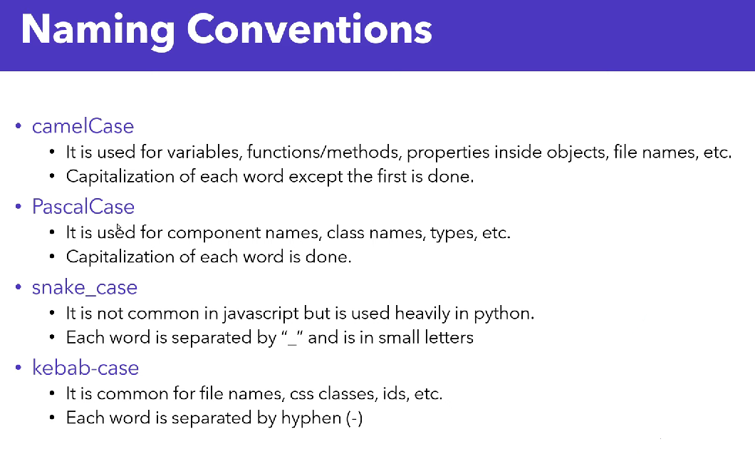

**Jsx - JavaScript XML**

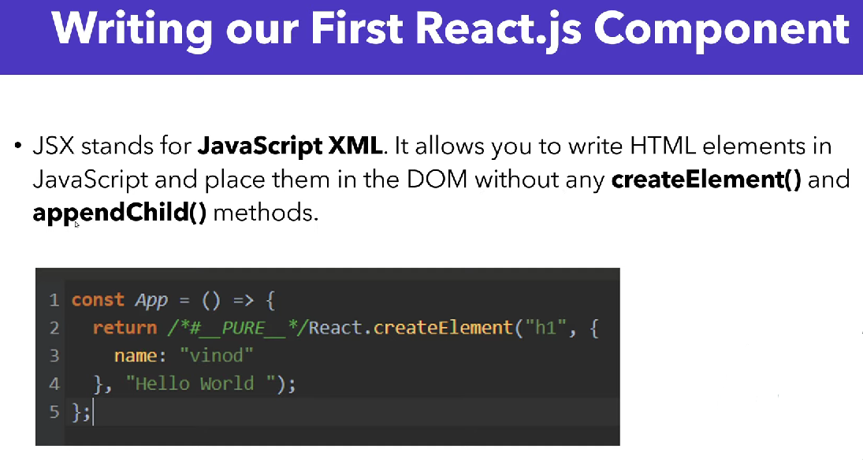**Does Babel convert JSX to JS?**

Browsers don't understand JSX out of the box, so most React users rely on a compiler like Babel or TypeScript to transform JSX code into regular JavaScript

**React has installed babel by default 👇**

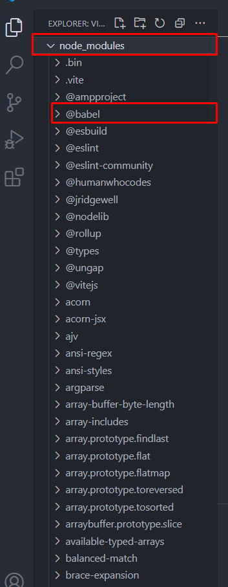

**Component**

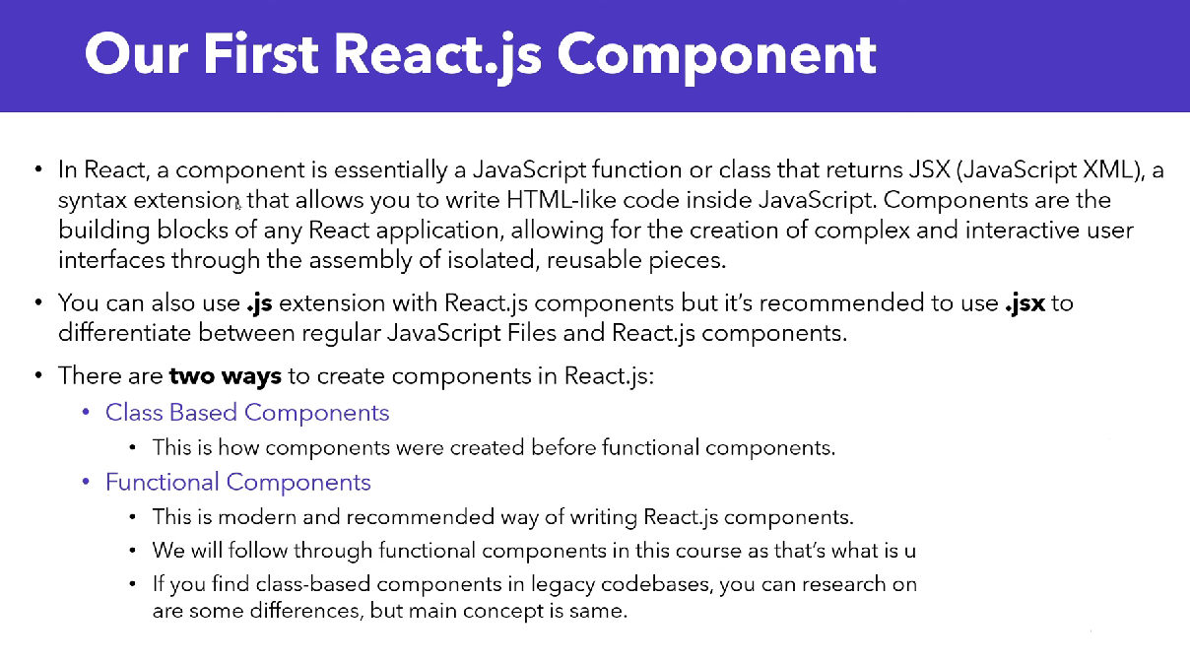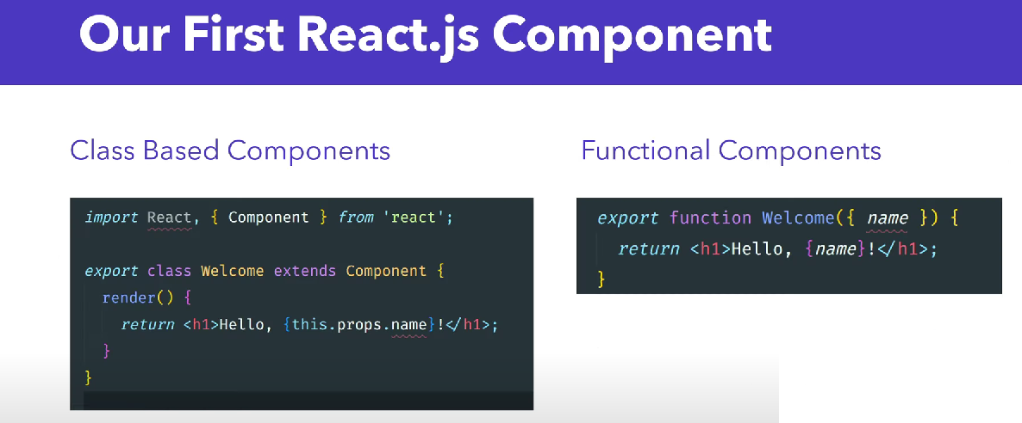

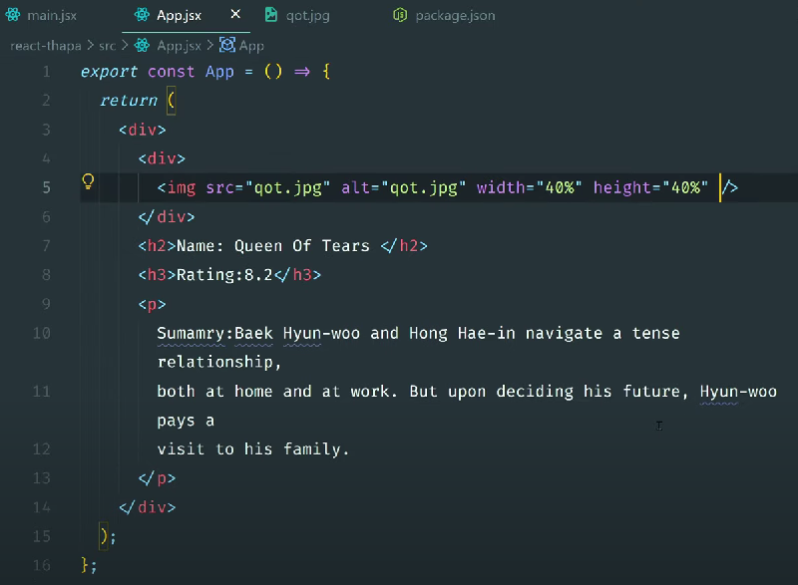

**React Fragment**

A common pattern in React is for a component to return multiple elements.   
Fragments let you group a list of children without adding extra nodes to the DOM.

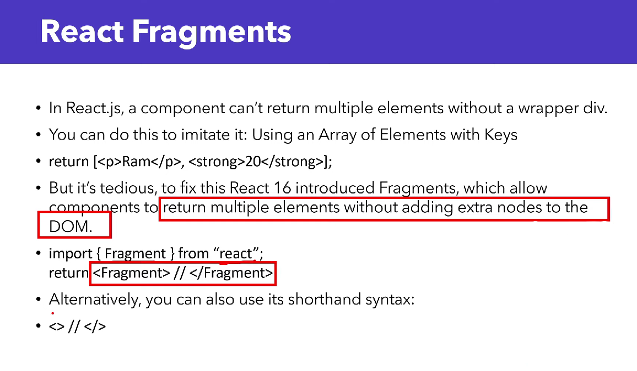

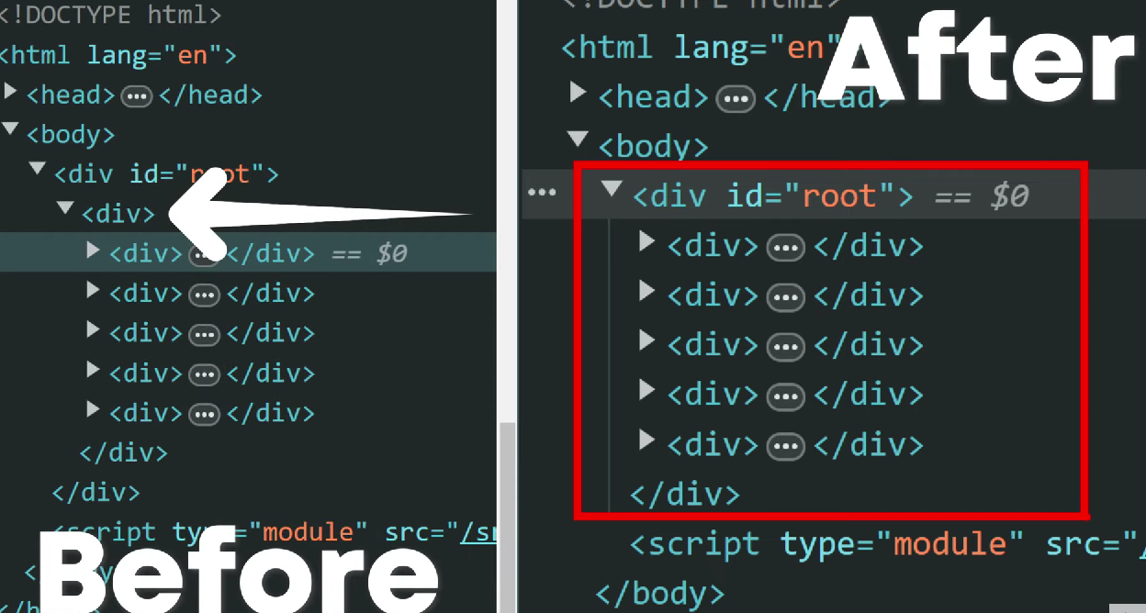

**Dynamic values in JSX**

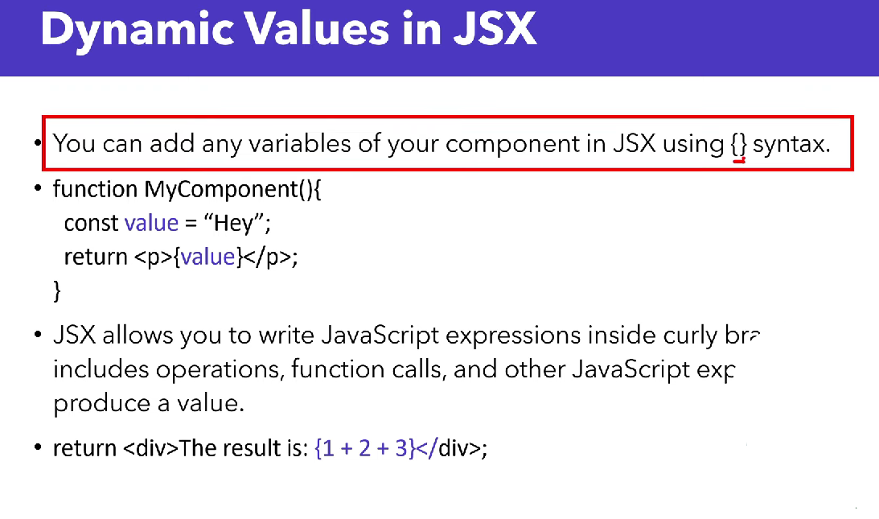

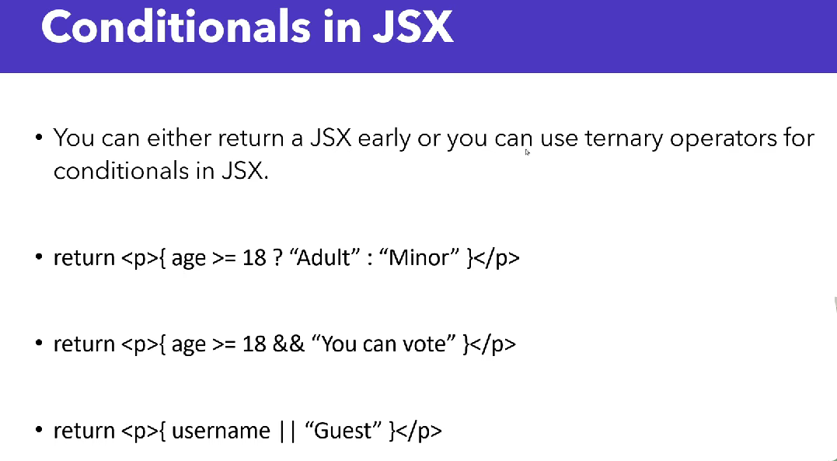

**Import and export**

<https://react.dev/learn/importing-and-exporting-components>

**Looping in JSX**

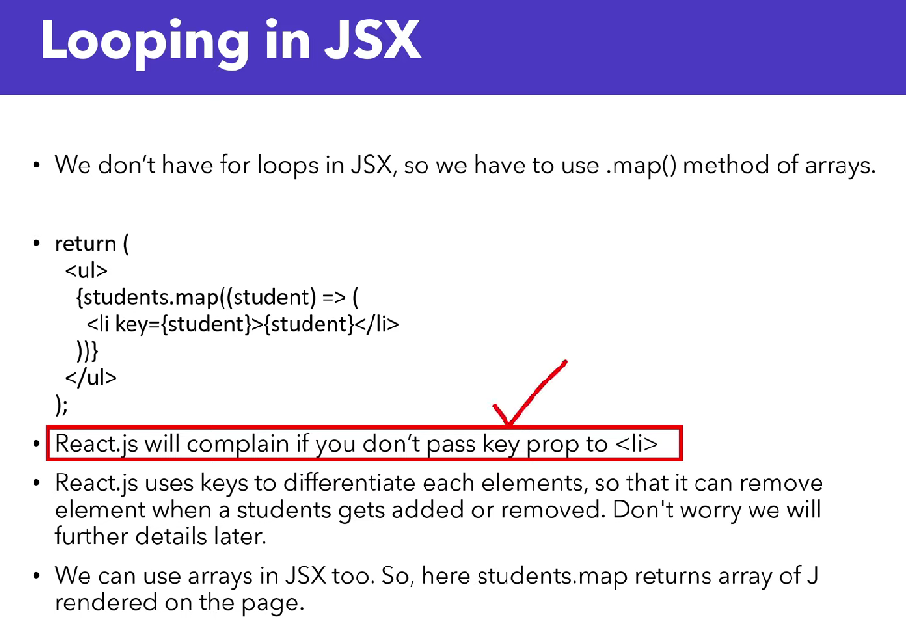

**Props in JSX**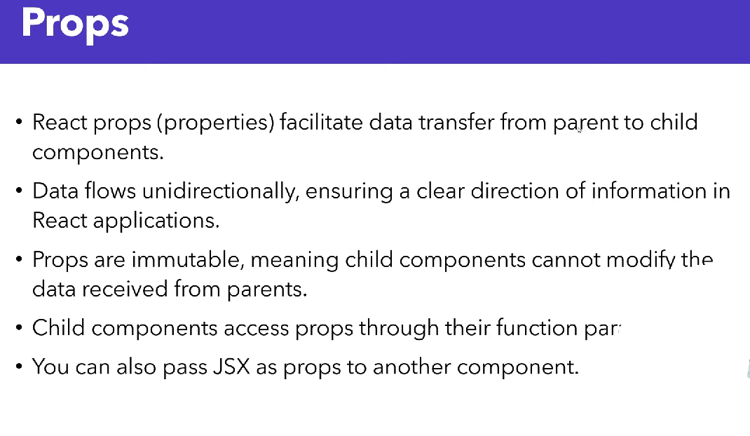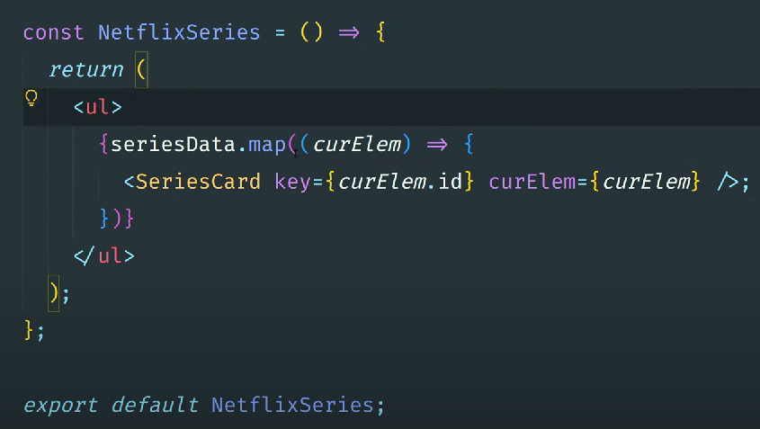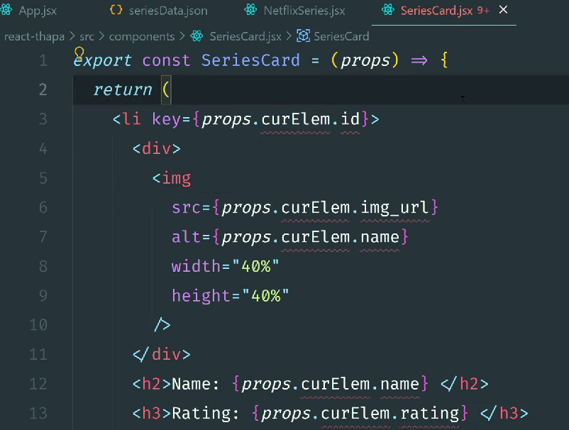

**Destructuring Props in JSX**

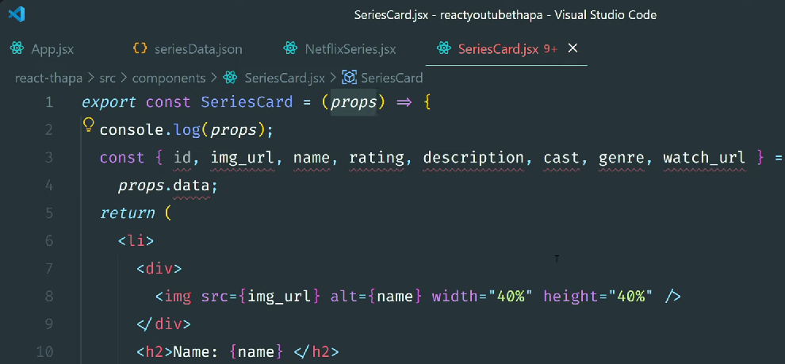

**– accept props in curly {} braces 👇**

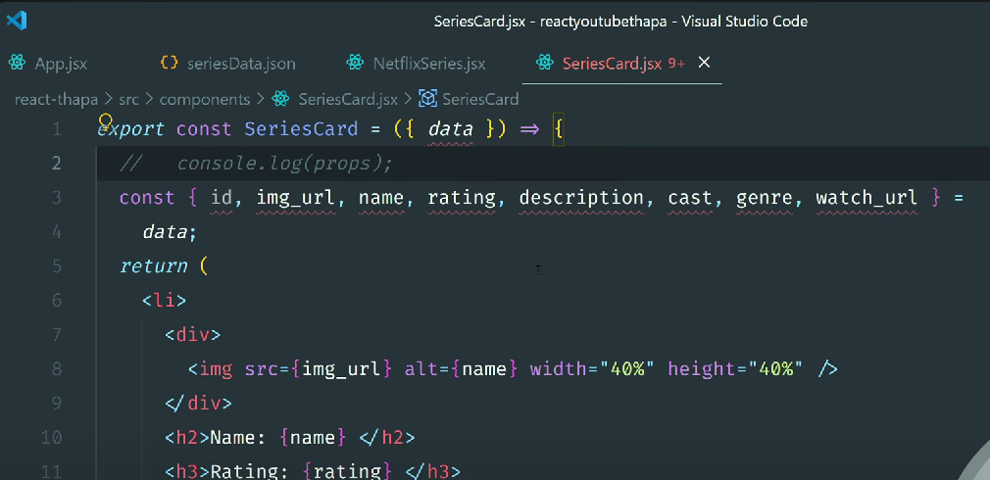

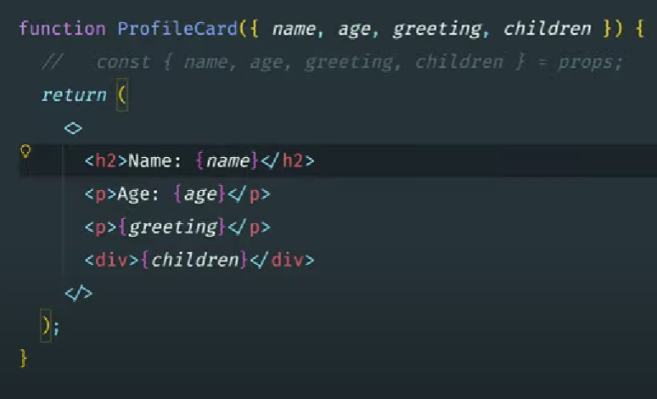

**How to Deal with Errors and Warnings👇**

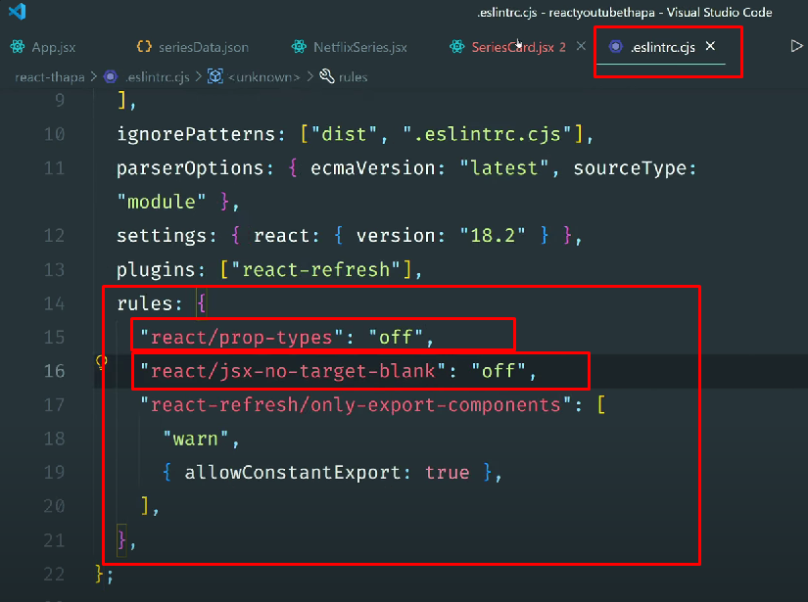

**Pass JSX as props👇**

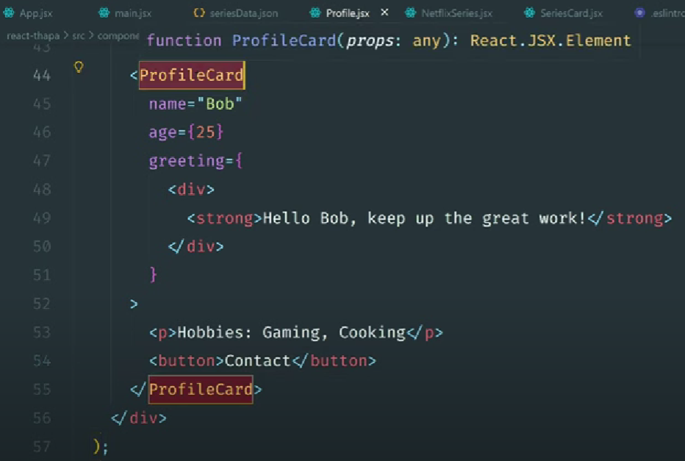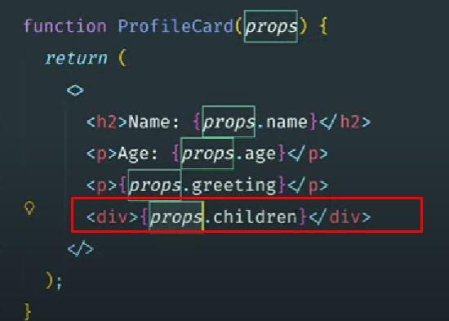

**Add CSS Styling in React: Class vs ClassName👇**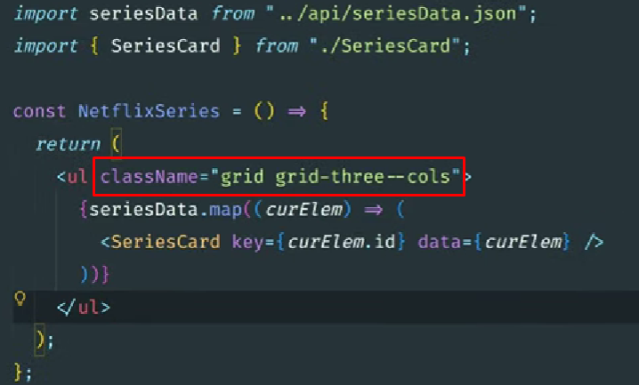

**–inline CSS 👇**

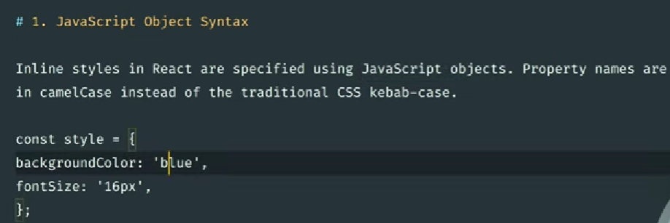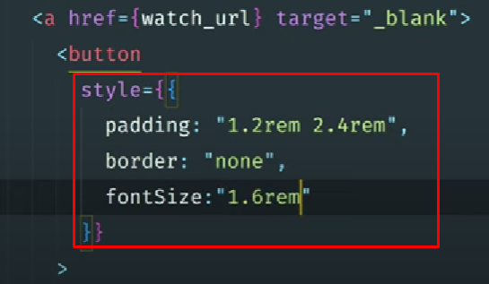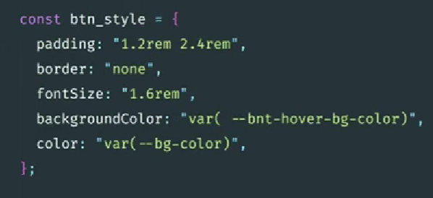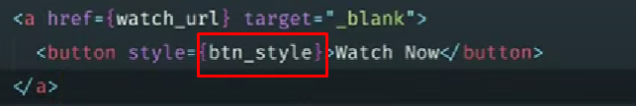

**Add conditional style👇**

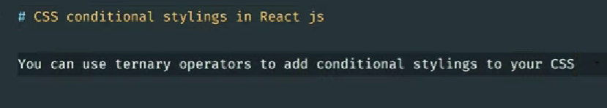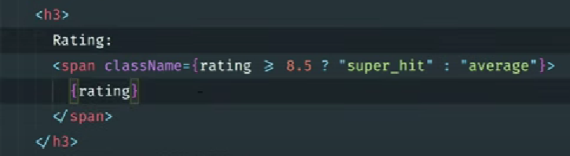

**Multiple classes with conditional class 👇**

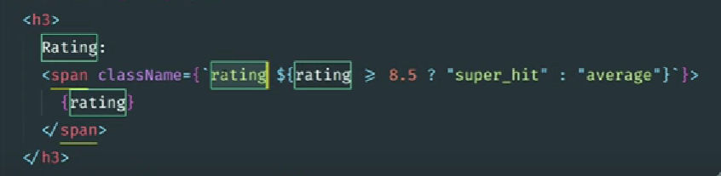

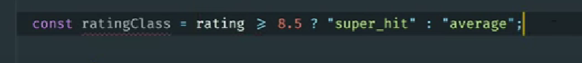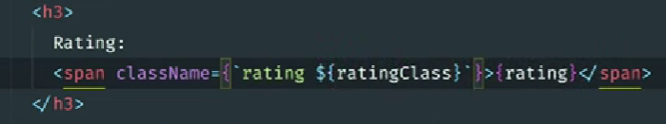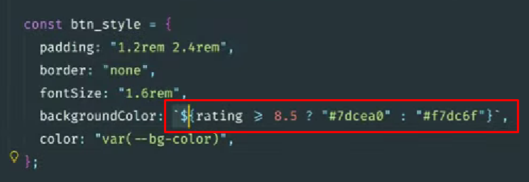

**CSS Modules in React: Scoped and Reusable Styles👇**

**Create separate css file for specific component and import in particular component**

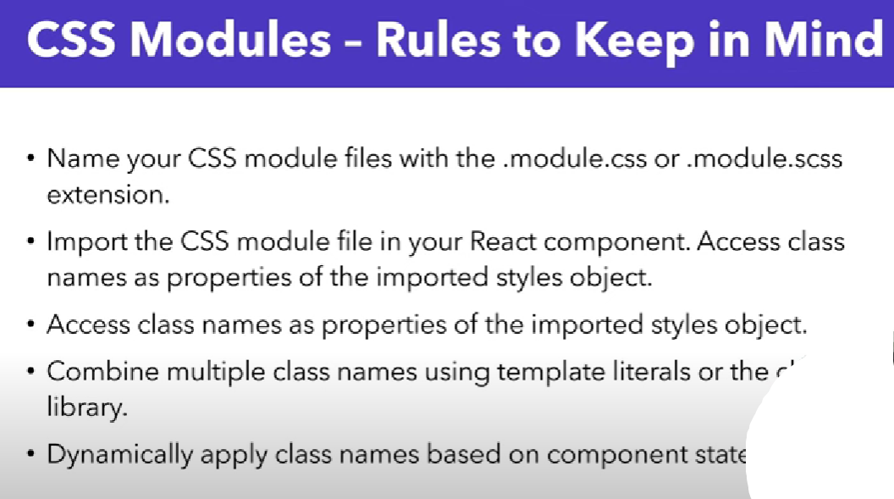

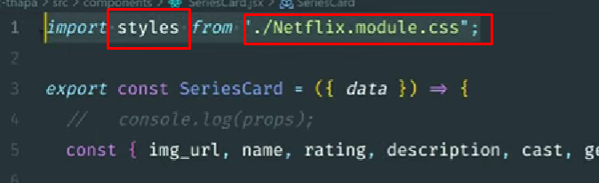

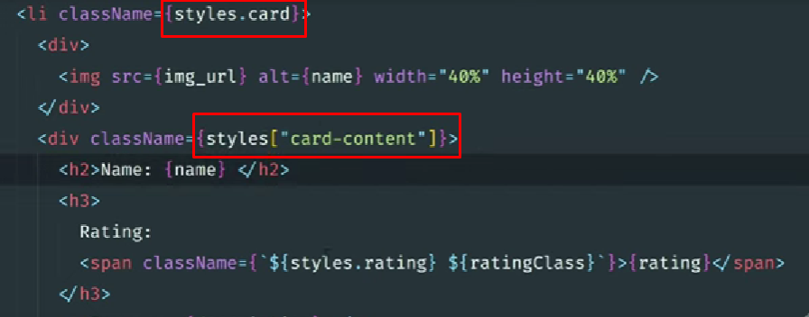

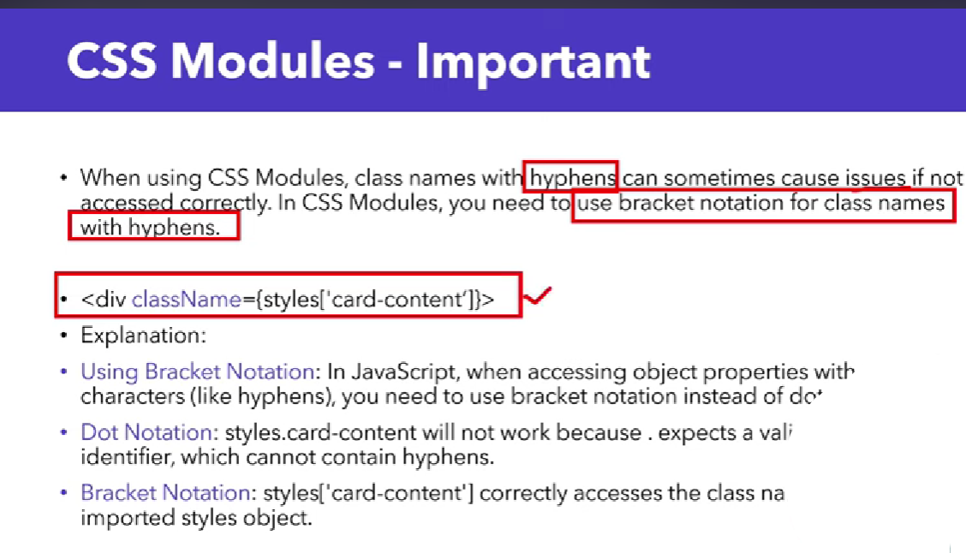

**Using CSS modules changes class names to unique class names on the front-end to prevent conflicts between the same classes used throughout the app.**

**For more info 👉** [**https://css-tricks.com/css-modules-part-1-need/**](https://css-tricks.com/css-modules-part-1-need/)

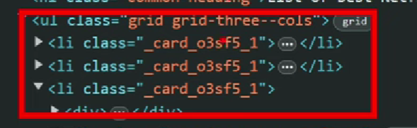

**Events Handling 👇**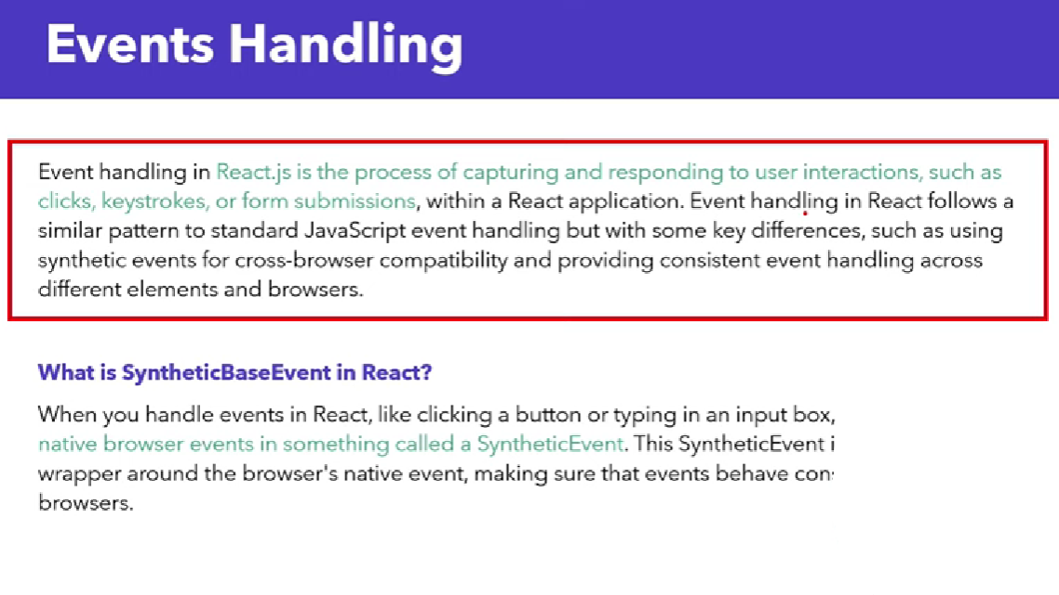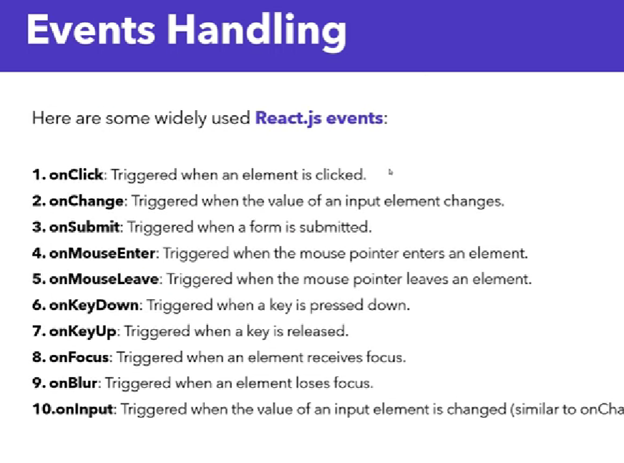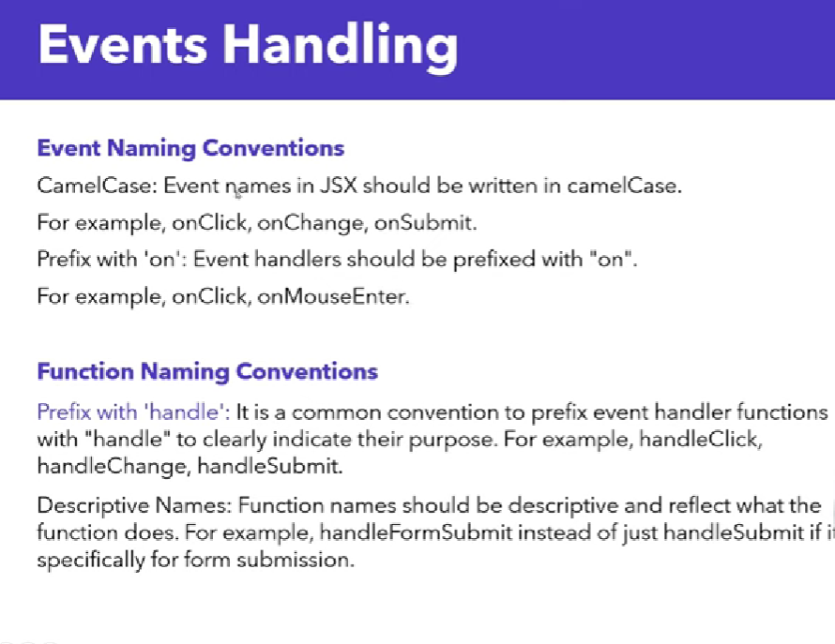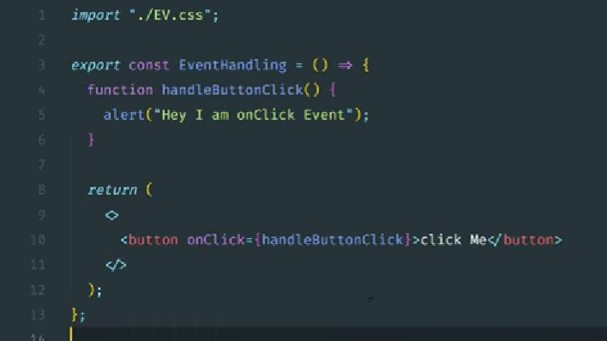

**Function calling with name and fat arrow function 👇**

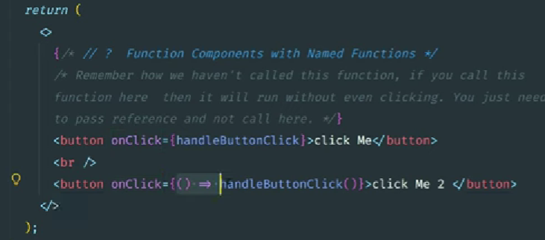

**Passing Events as Props in React | Control Parent Function Using Child Component 👇**

**Parent 👇**

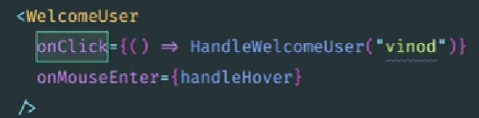

**Child 👇**

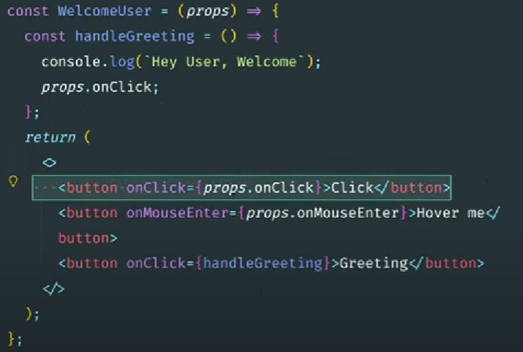

**Destructuring 👇**

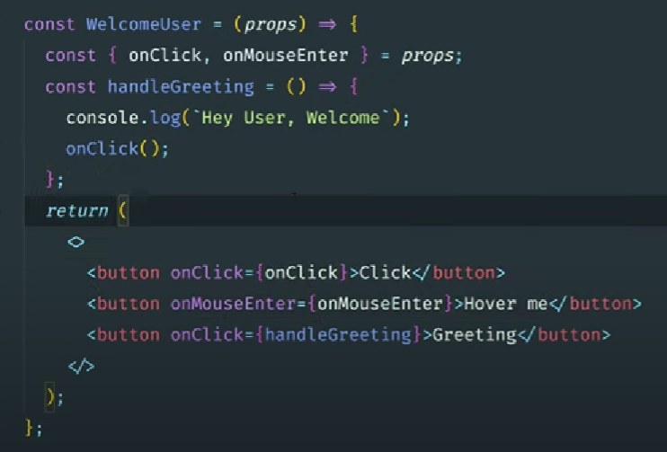

**Event Propagation 👇**

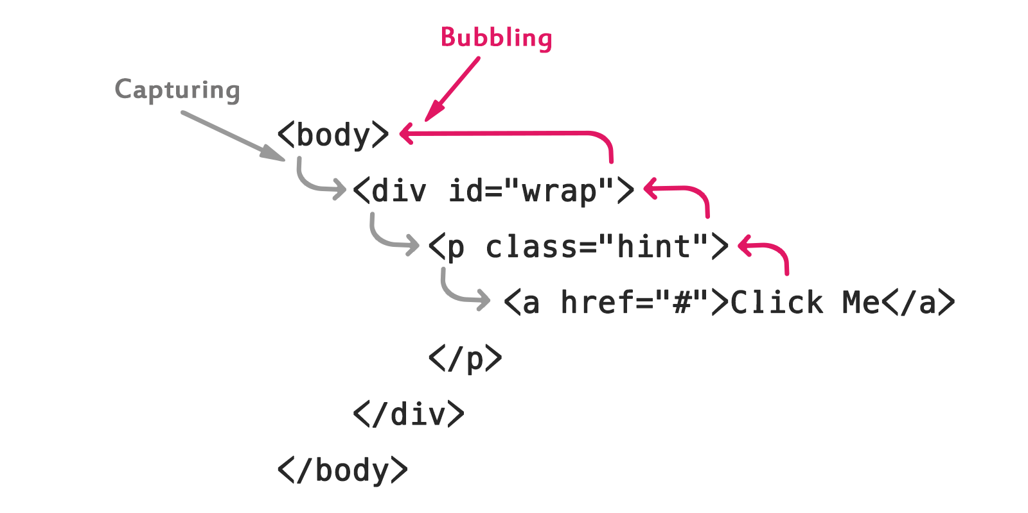

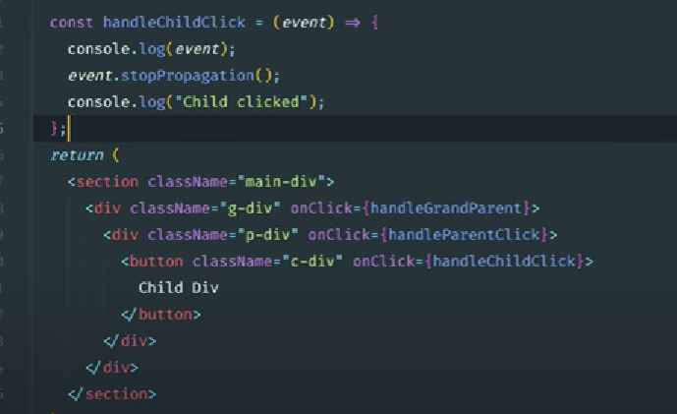

**Event Capture phase in react 👇**

**onClickCapture(your function here)**

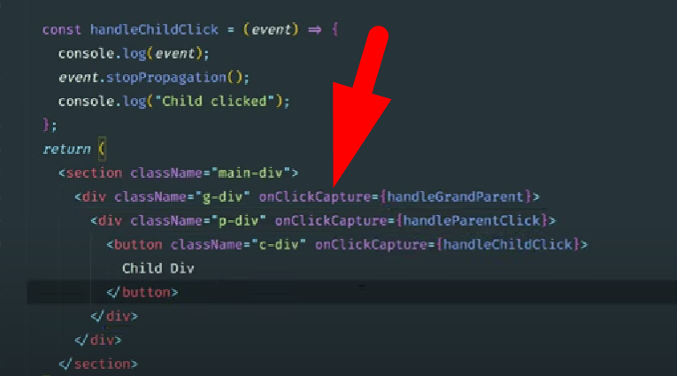

**States 👇**

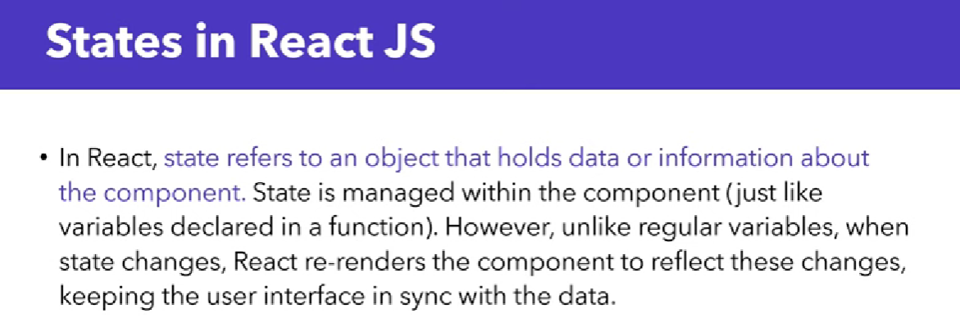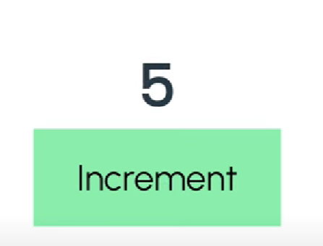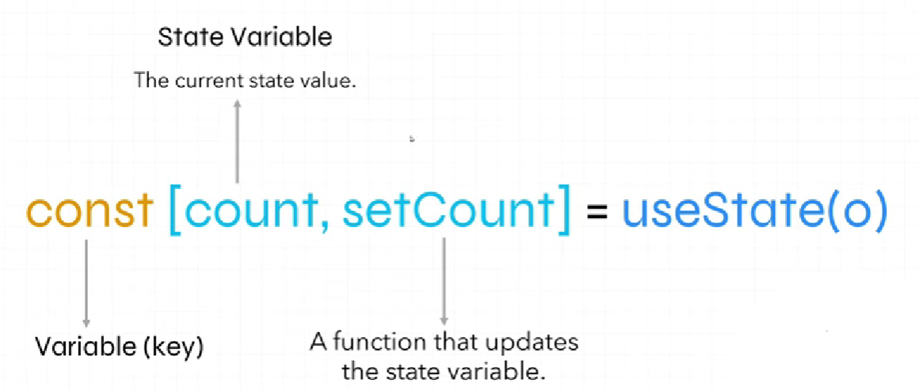

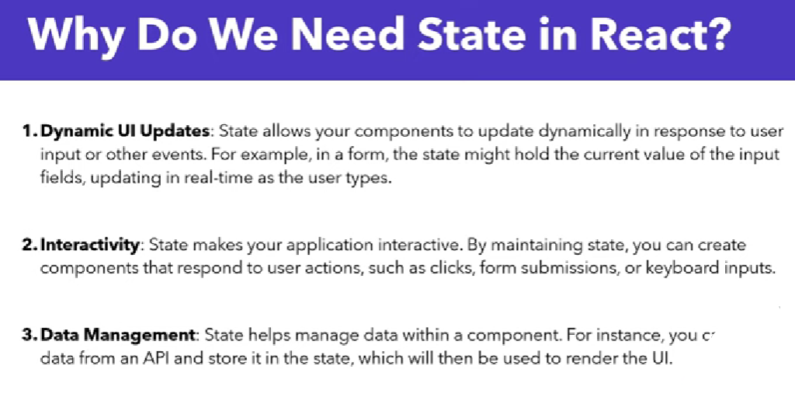

**Lifting the state up**

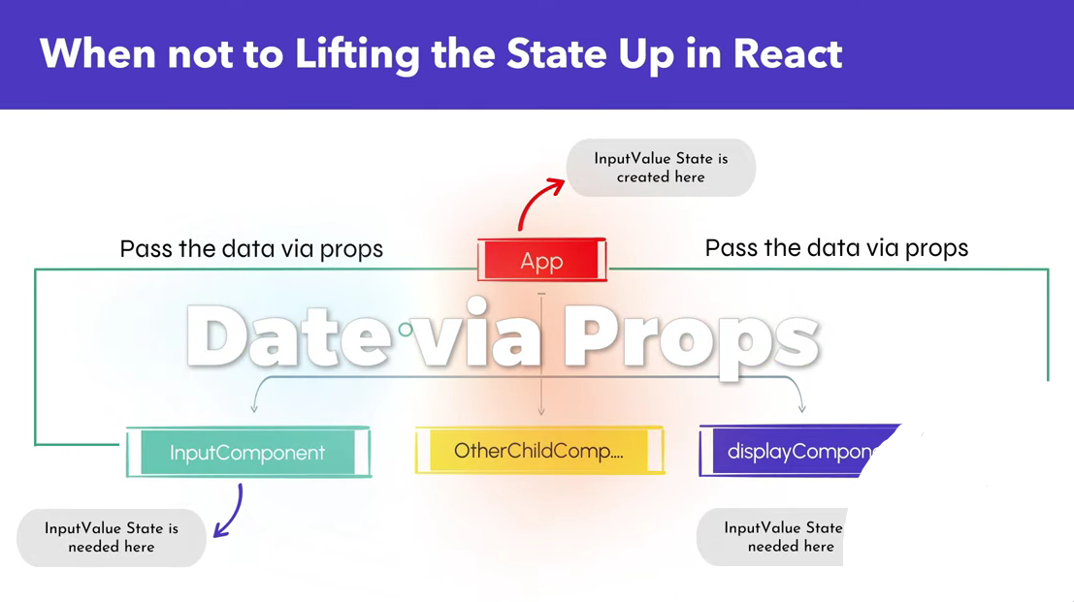

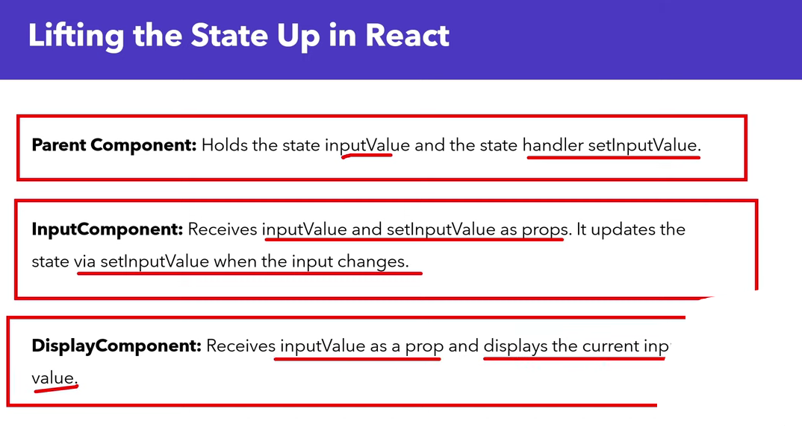

**App.jsx 👇**

**import { useState } from "react";**

**import ParentCom from "./ParentCom";**

**import ChildCom from "./ChildCom";**

**export const App = () => {**

**let [count, updateCount] = useState(0);**

**return (**

**<>**

**<ParentCom *count*={count} *updateCount*={updateCount} />**

**<ChildCom *count*={count} />**

**</>**

**)**

**}**

**ParentCom.jsx 👇**

**function ParentCom(*props*) {**

**return (**

**<>**

**<h1>{*props*.count}</h1>**

**<button *onClick*={() => *props*.updateCount(*props*.count + 1)}>Click me</button>**

**</>**

**)**

**}**

**export default ParentCom;**

**ChildCom.jsx 👇**

**function ChildCom(*props*) {**

**return (**

**<>**

**<p>Your count is {*props*.count}</p>**

**</>**

**)**

**}**

**export default ChildCom;**

**Toggle Switch**

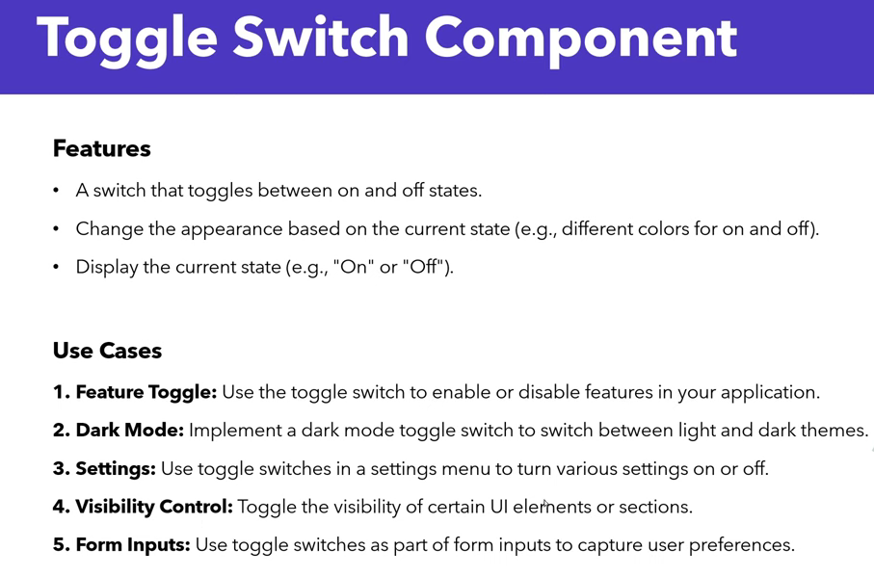

import { useState } from "react"

export const ToggleSwitch = () => {

const [isOn, setIsOn] = useState(false);

return (

<>

<p>{isOn ? "On" : "Off"}</p>

<label *className*={`switch ${isOn ? "On" : "Off"}`} *onClick*={() => setIsOn(!isOn)}>

<span *className*="slider"></span>

</label>

</>

)

}

**More simplify 👇**

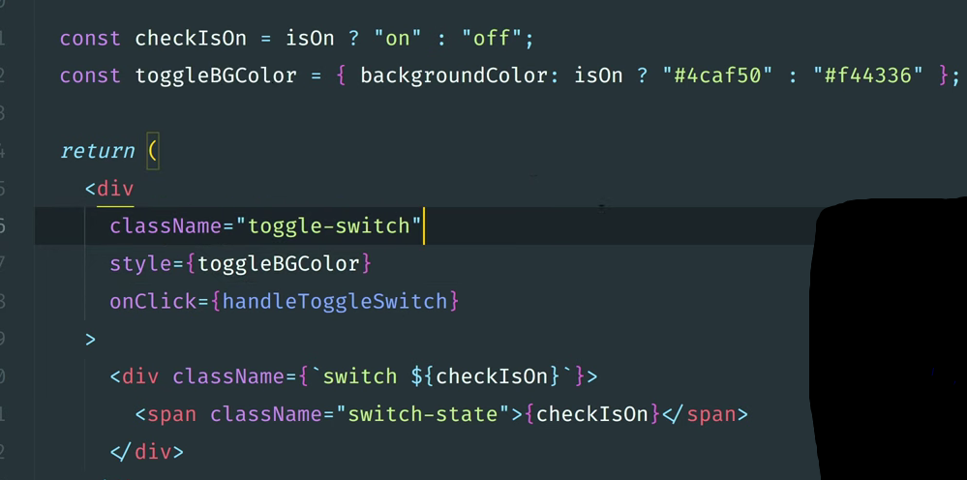

**React Icons**

<https://www.npmjs.com/package/react-icons>

**bun i react-icons**

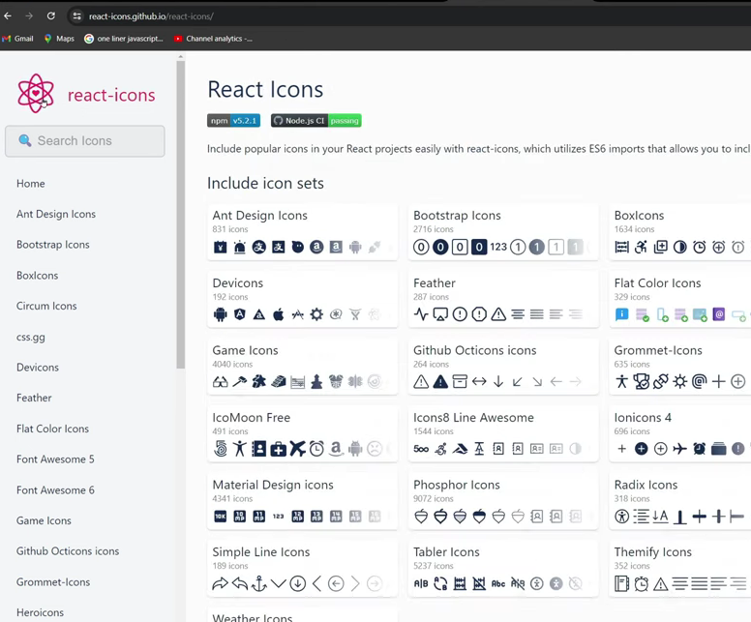

**UseEffect CleanUp**

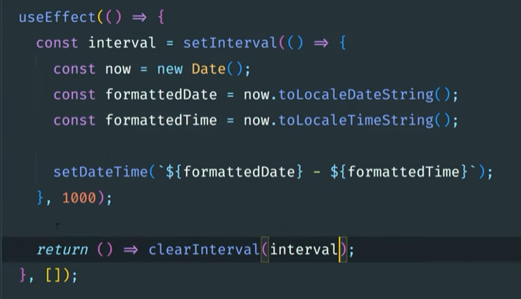

import { useState, useEffect } from "react"

export const DateTime = () => {

const [Time, SetTime] = useState(0);

useEffect(() => {

const timeInterval = setInterval(() => {

const d = new Date();

const time = d.toLocaleString();

console.log(time);

SetTime(time);

}, 1000);

return () => clearInterval(timeInterval);

}, [])

return (

<p>{Time}</p>

)

}

**ToDo App**

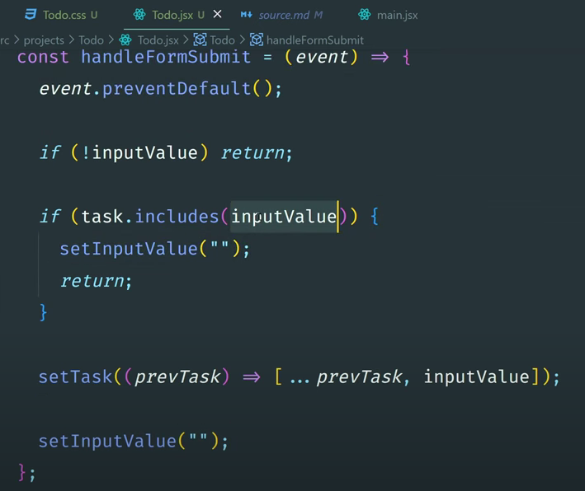

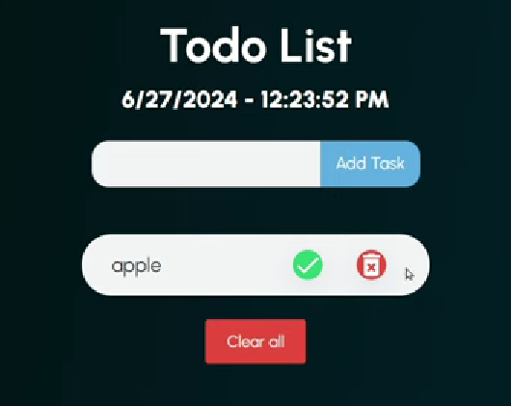

**After creating your TODO app, host it for free.**

First create a **production build** (version) from your development environment.

bun run build

**Live your app**

<https://app.netlify.com/login>

**Short Circuit Evaluation**

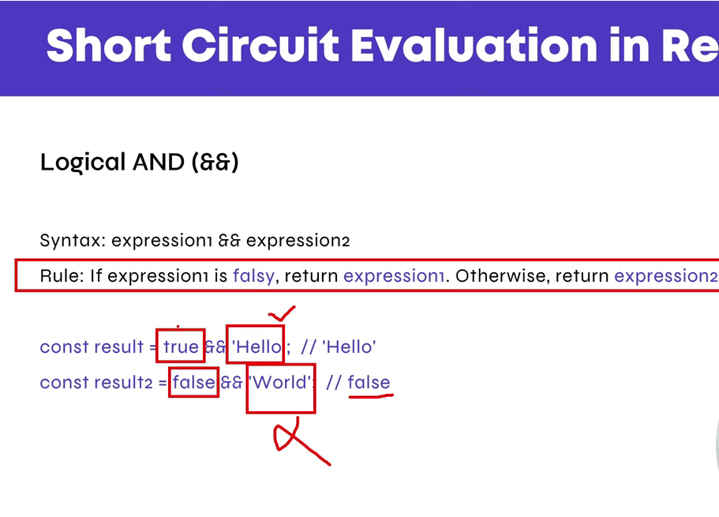

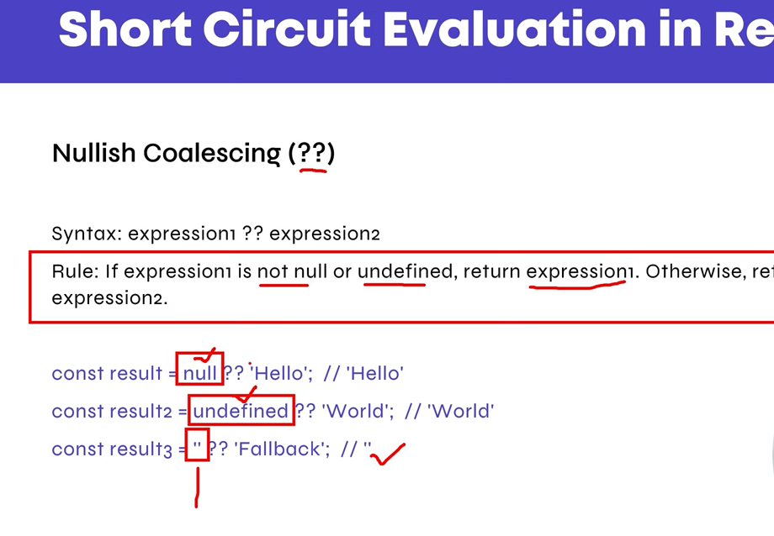

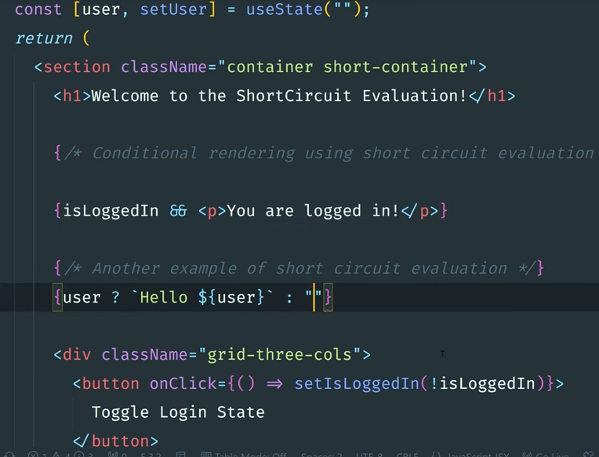

*// inputVal && "";*

*// !inputVal && alert("");*

*// if (!inputVal) return;*

!*inputVal* ? (alert("Please enter data"), false) : alert("Data added");

*// if (todoArr.includes(inputVal)) return;*

const isExistInArr = *todoArr*.find(*element* => {

return *element*.content == *inputVal*;

});

**Hooks Rules**

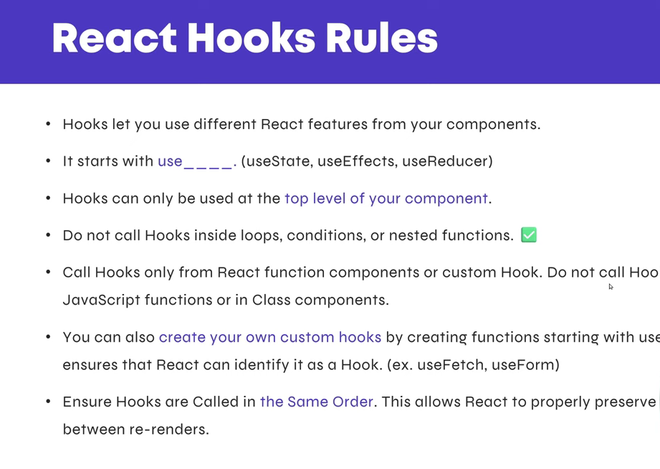

**useState Hook**

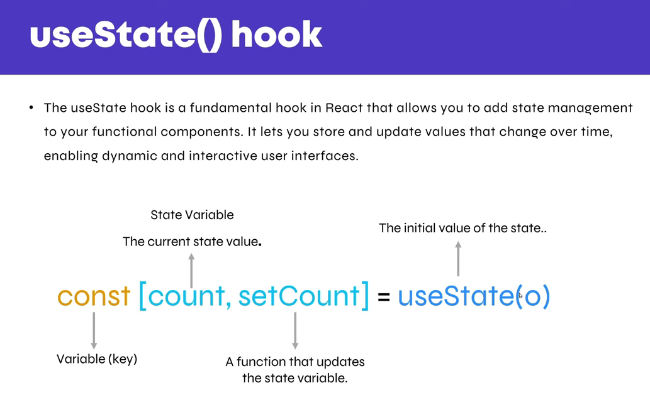

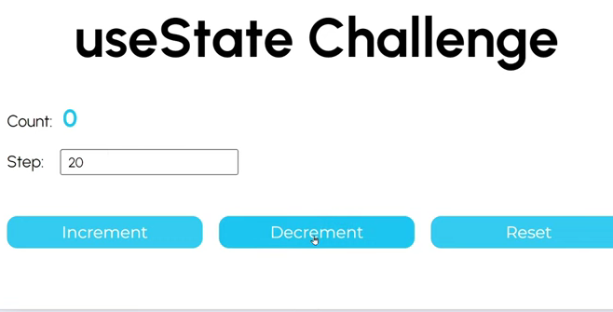

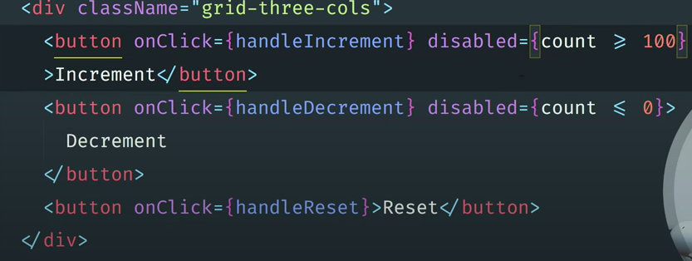

**Controlled Component**

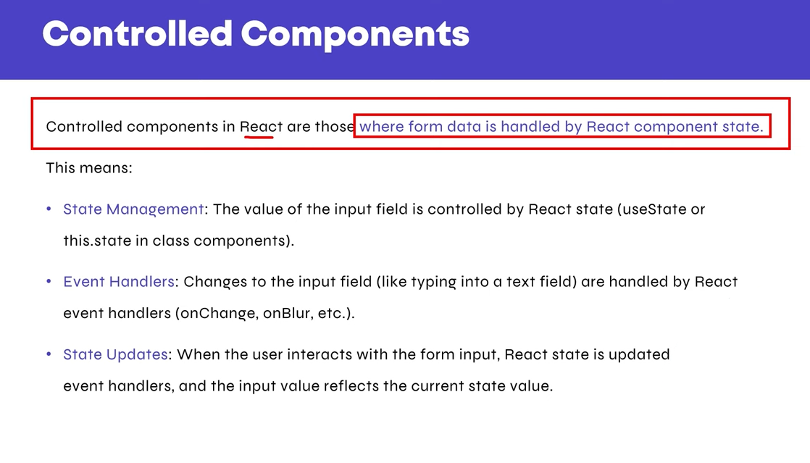

**UnControlled Component**

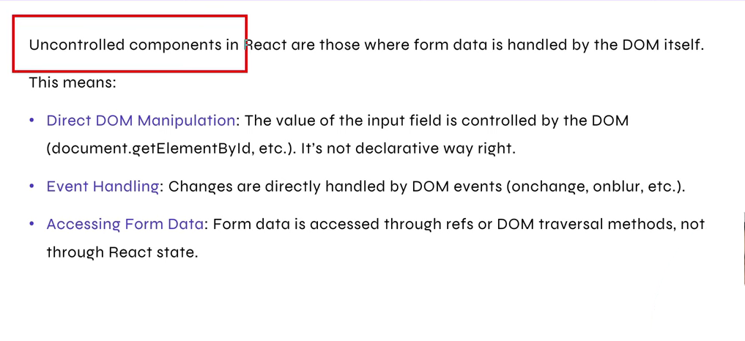

**Form Handling**

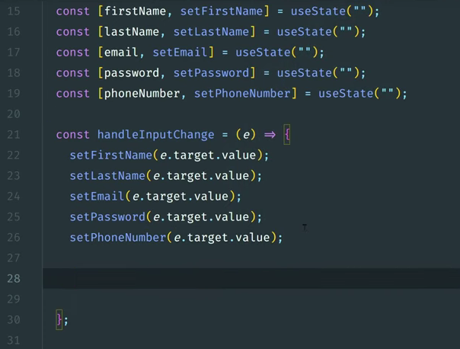

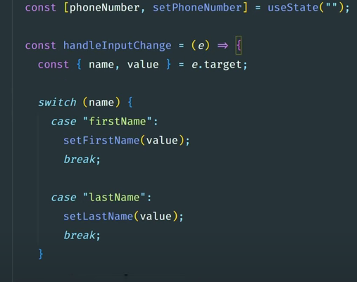

**Object**

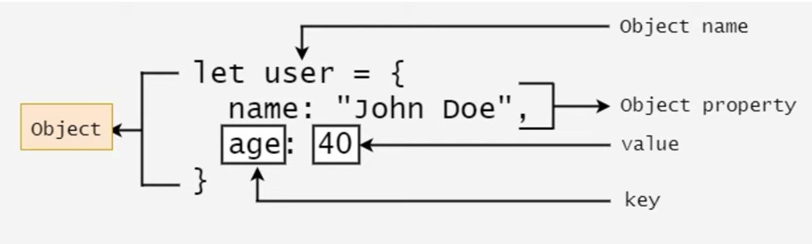

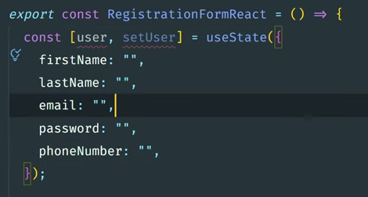

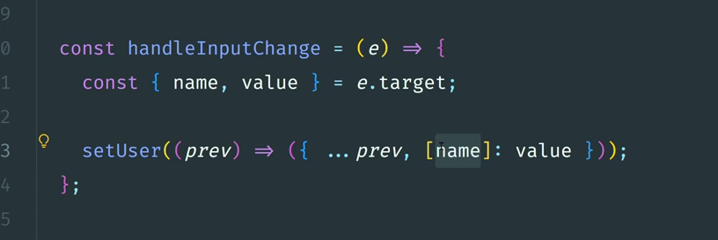

**Contact Form**

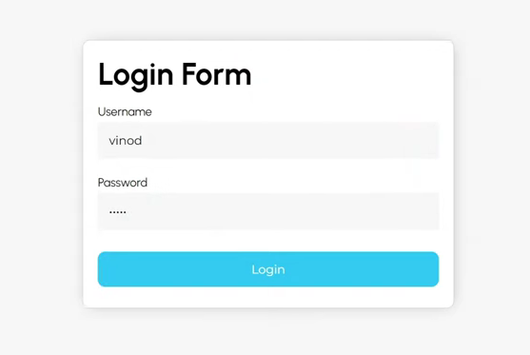

import { useState } from "react";

export const Form = () => {

const [formData, setFormData] = useState({

name: "",

email: "",

message: "",

});

const onChangeHandler = (*e*) => {

const { name, value } = *e*.target;

setFormData((*prev*) => ({ ...*prev*, [name]: value }));

};

const formSubmit = (*e*) => {

*e*.preventDefault();

};

return (

<section>

<div *className*="container">

<form *onSubmit*={formSubmit}>

<div *className*="input_wrap">

<input

*type*="text"

*name*="name"

*value*={formData.name}

*onChange*={onChangeHandler}

/>

</div>

<div *className*="input_wrap">

<input

*type*="email"

*name*="email"

*value*={formData.email}

*onChange*={onChangeHandler}

/>

</div>

<div *className*="input_wrap">

<textarea

*name*="message"

*value*={formData.message}

*onChange*={onChangeHandler}

></textarea>

</div>

<div *className*="submit_wrap">

<input *type*="submit" *value*="Submit" />

</div>

</form>

</div>

</section>

);

};

**useRef Hook (Form with useRef Hook)**

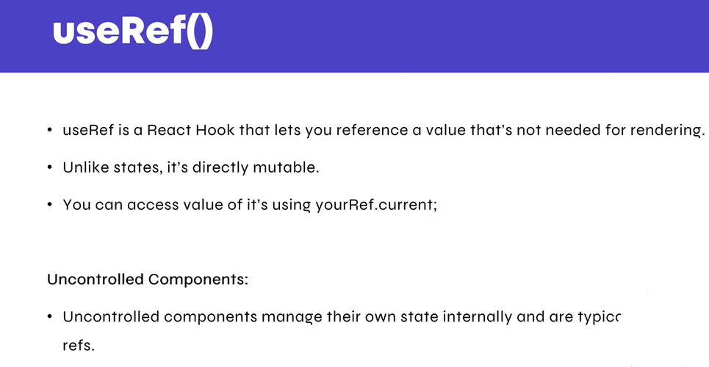

import { useRef, useState } from "react";

export const FormWithUseRef = () => {

const [formData, setFormData] = useState({});

const name = useRef(null);

const email = useRef(null);

const message = useRef(null);

console.log(name);

const formSubmit = (*e*) => {

*e*.preventDefault();

setFormData(() => ({

name: name.current.value,

email: email.current.value,

message: message.current.value,

}));

console.log(formData);

};

return (

<section>

<div *className*="container">

<form *onSubmit*={formSubmit}>

<div *className*="input_wrap">

<input *type*="text" *name*="name" *ref*={name} />

</div>

<div *className*="input_wrap">

<input *type*="text" *name*="email" *ref*={email} />

</div>

<div *className*="input_wrap">

<textarea *name*="message" *ref*={message}></textarea>

</div>

<div *className*="submit_wrap">

<input *type*="submit" *value*="Submit" />

</div>

</form>

</div>

</section>

);

};

**useEffect Hook**

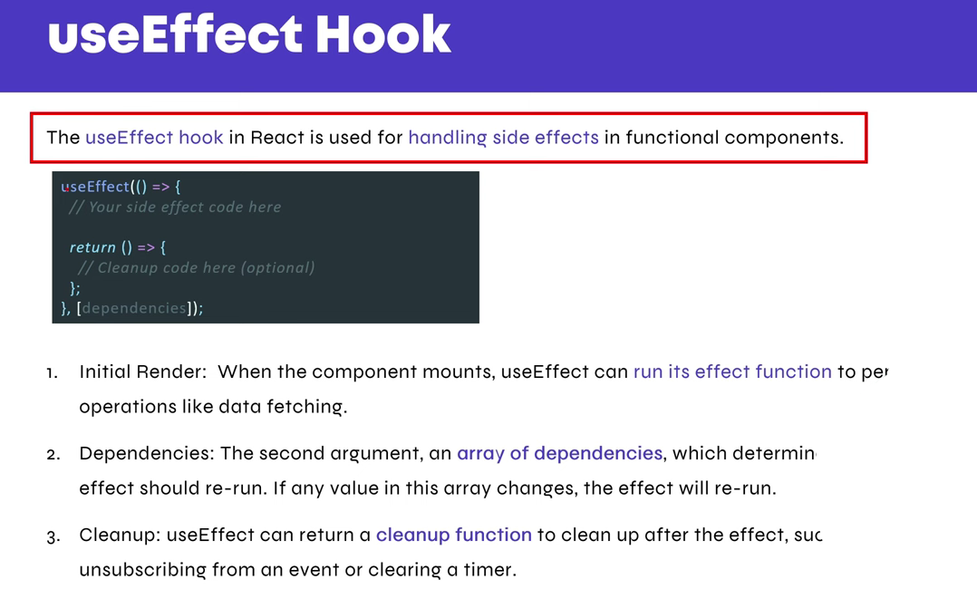

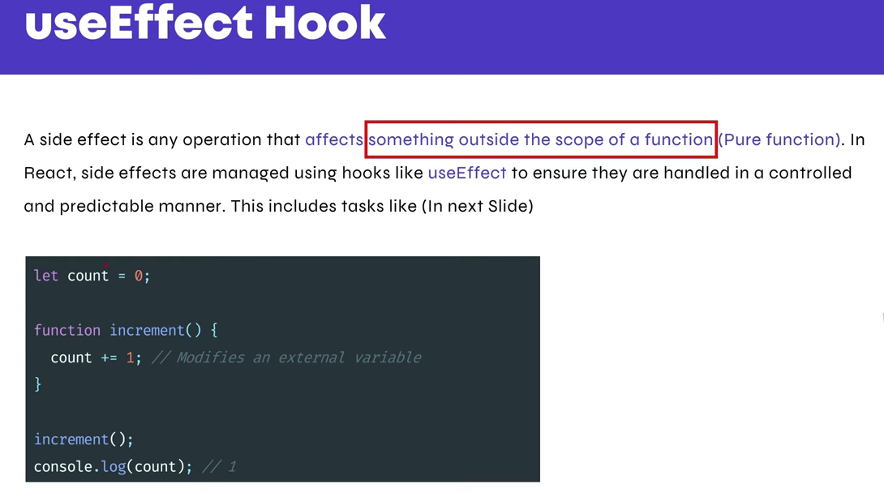

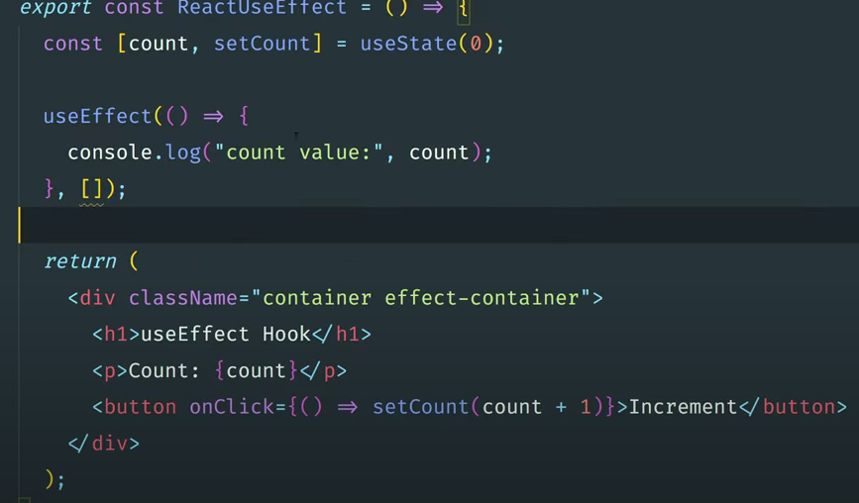

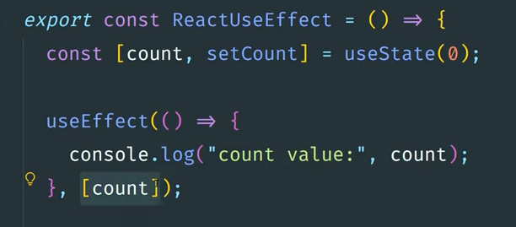

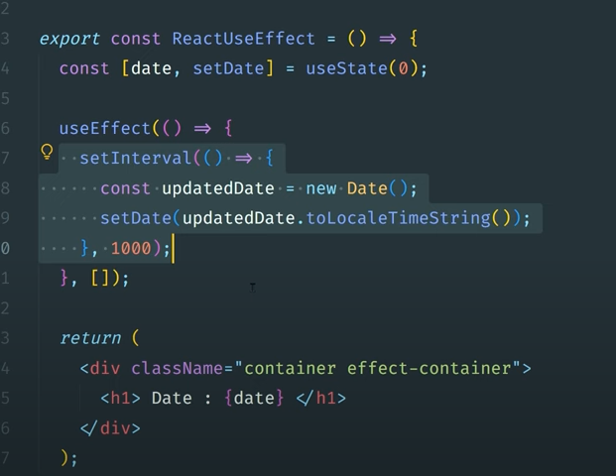

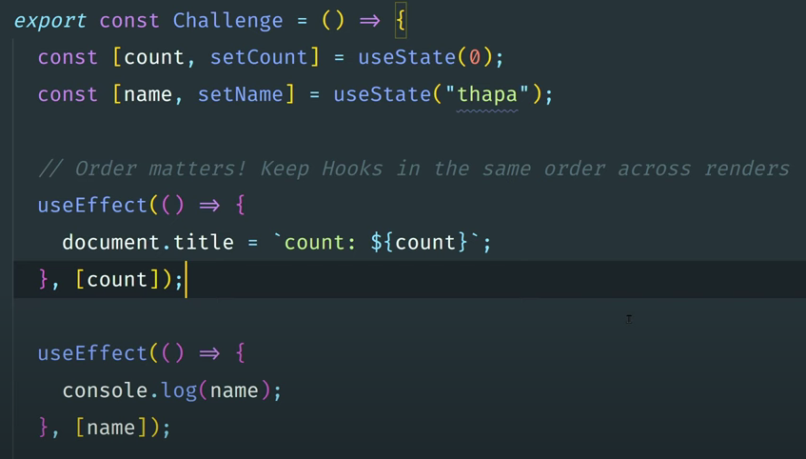

**useEffect CleanUp function**

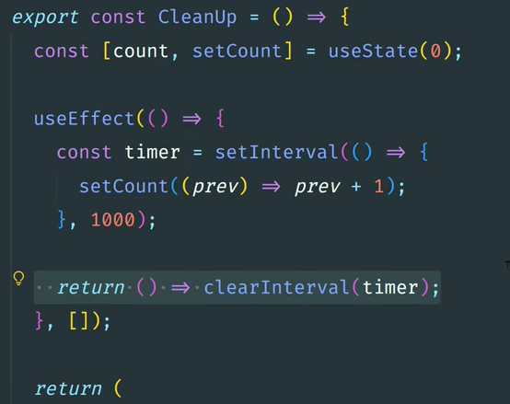

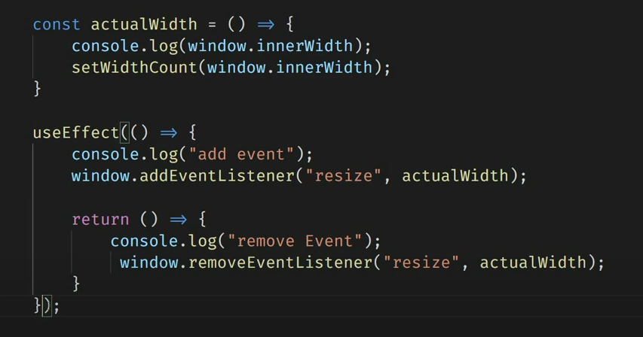

**HowNotToFetchApi**

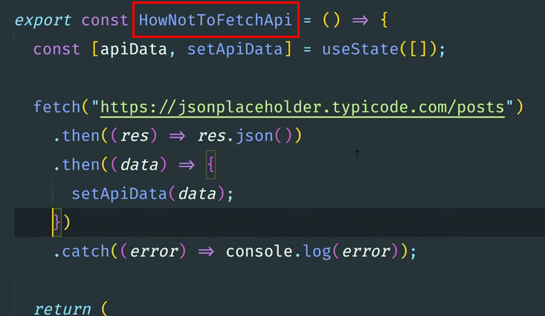

**Right way to fetch using useEffect Hook**

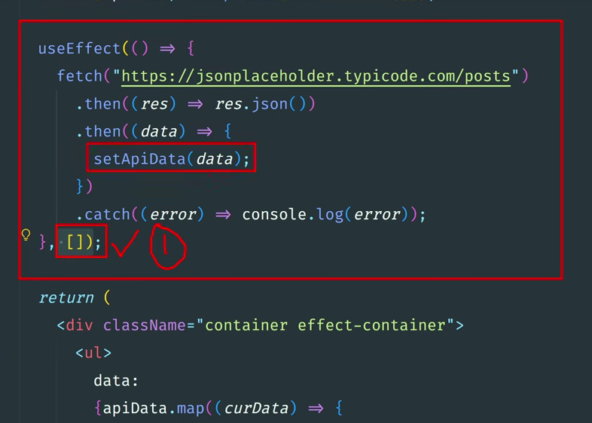

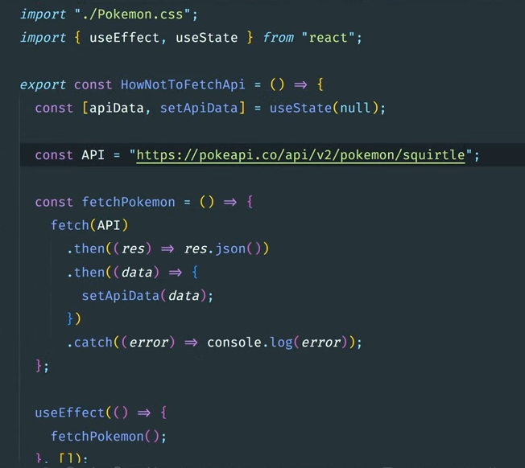

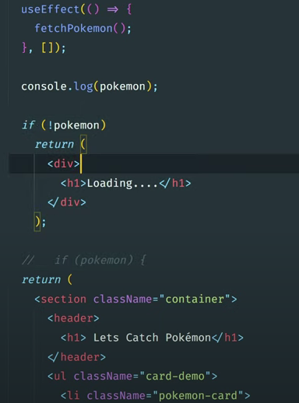

**Set and throw error while fetch data from API**

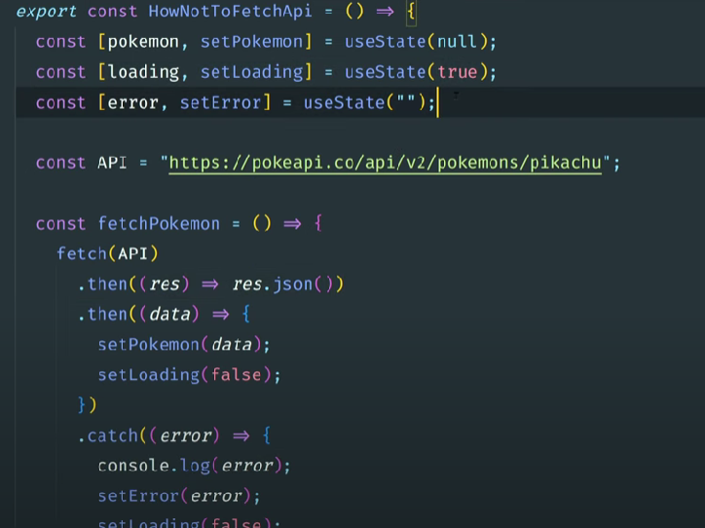

**Using Async Await method**

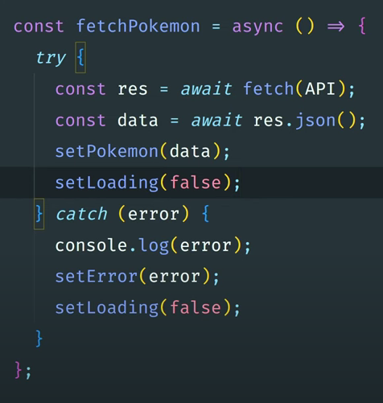

**get rid of an ESLint error**

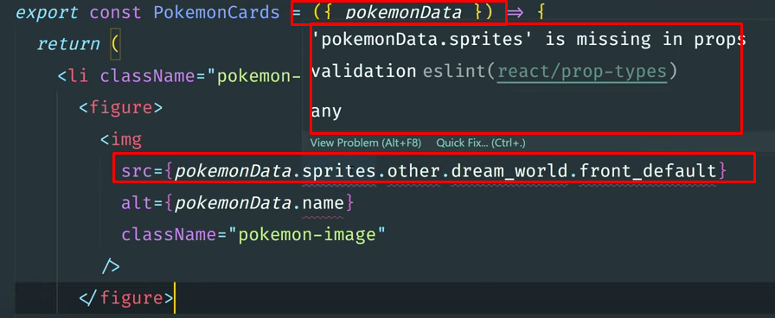

**In eslintrc.cjs add this line (screenshot below)**

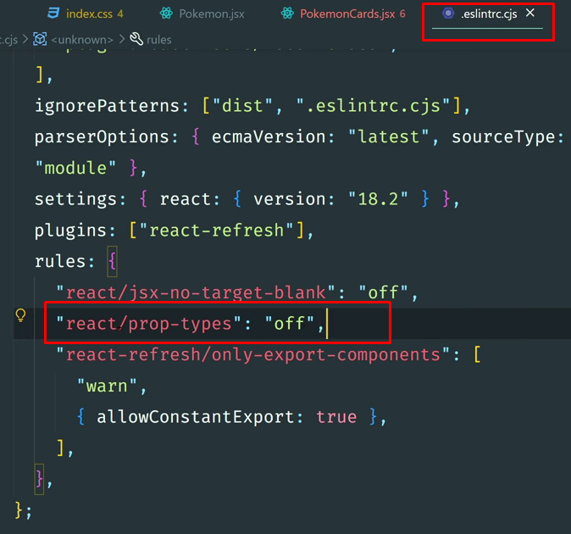

**Pokemon Api**

Preview Live URL = "<https://pokapis.netlify.app/>";

<https://pokapis.netlify.app/>

**AXIOS - Data from an API**

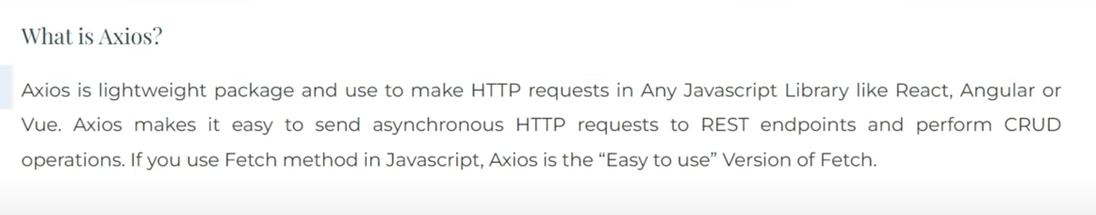

let [apiData, setApiData] = useState([]);

useEffect(() => {

let axiosInstance = axios.create({

baseURL: "https://jsonplaceholder.typicode.com/photos",

});

axiosInstance

.get("/")

.then((*response*) => {

console.log(*response*.data);

setApiData(*response*.data);

})

.catch((*error*) => {

console.error("Error fetching data:", *error*);

});

console.log(apiData);

}, []);

bun i axios

**Install bootstrap**

<https://www.npmjs.com/package/bootstrap>

npm i bootstrap

Bun i bootstrap

import 'bootstrap/dist/css/bootstrap.css';

In main.jsx 👇

import 'bootstrap/dist/css/bootstrap.css';

**Form Validation**



<https://www.npmjs.com/package/formik>

bun i formik

<https://www.npmjs.com/package/yup>

bun i yup

import {useFormik} from 'formik';

import {useFormik} from 'formik';

**Form handling with Formik**

**import { useFormik } from 'formik';**

**const initialValues = {**

**name: "",**

**email: "",**

**password: "",**

**con_password: "",**

**}**

**export const Form = () => {**

***// const Formik = useFormik({***

***// initialValues: initialValues,***

***// onSubmit: (values) => {***

***// console.log(values);***

***// }***

***// })***

***// value={Formik.values.name}***

**const { values, errors, handleBlur, handleChange, handleSubmit } = useFormik({ *//destructured***

**initialValues: initialValues,**

**onSubmit: (*values*) => {**

**console.log(*values*);**

**}**

**})**

**return (**

**<>**

**<section>**

**<div *className*="container">**

**<div *className*="row">**

**<div *className*="col-10">**

**<form *onSubmit*={handleSubmit}>**

**<div *className*="mb-3">**

**<label *htmlFor*="name" *className*="form-label">Name</label>**

**<input *type*="text" *name*='name' *className*="form-control" *id*="name" *autoComplete*='false' *value*={values.name} *onChange*={handleChange} *onBlur*={handleBlur} />**

**</div>**

**<div *className*="mb-3">**

**<label *htmlFor*="email" *className*="form-label">Email address</label>**

**<input *type*="email" *name*='email' *className*="form-control" *id*="email" *autoComplete*='false' *value*={values.email} *onChange*={handleChange} *onBlur*={handleBlur} />**

**</div>**

**<div *className*="mb-3">**

**<label *htmlFor*="password" *className*="form-label">Password</label>**

**<input *type*="password" *name*='password' *className*="form-control" *id*="password" *autoComplete*='false' *value*={values.password} *onChange*={handleChange} *onBlur*={handleBlur} />**

**</div>**

**<div *className*="mb-3">**

**<label *htmlFor*="con_password" *className*="form-label">Confirm Password</label>**

**<input *type*="con_password" *name*='con_password' *className*="form-control" *id*="con_password" *autoComplete*='false' *value*={values.con_password} *onChange*={handleChange} *onBlur*={handleBlur} />**

**</div>**

**<button *type*="submit" *className*="btn btn-primary">Submit</button>**

**</form>**

**</div>**

**</div>**

**</div>**

**</section>**

**</>**

**)**

**}**

**Create schema folder inside src folder 👇**

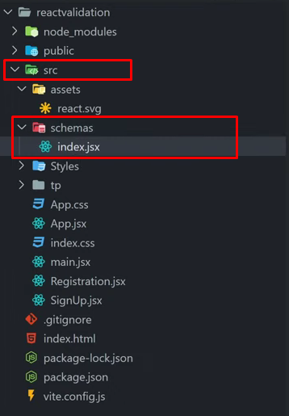

**Inside index.jsx 👇**

**import * as Yup from "yup";**

**export const signUpSchema = Yup.object({**

**name: Yup.string().min(2).max(25).required("Please enter your name"),**

**email: Yup.string().email().required("Please enter your email"),**

**password: Yup.string().min(6).required("Please enter your password"),**

**con_password: Yup.string().required().oneOf([Yup.ref("password"), null], "Password must match"),**

**});**

**Complete form.jsx 👇**

import { useFormik } from 'formik';

import { signUpSchema } from "./schema"

const initialValues = {

name: "",

email: "",

password: "",

con_password: "",

}

export const Form = () => {

*// const Formik = useFormik({*

*// initialValues: initialValues,*

*// onSubmit: (values) => {*

*// console.log(values);*

*// }*

*// })*

*// value={Formik.values.name}*

const { values, errors, handleBlur, touched, handleChange, handleSubmit } = useFormik({ *//destructured*

initialValues: initialValues,

validationSchema: signUpSchema,

validateOnChange: true,

onSubmit: (*values*, { *resetForm* }) => {

console.log(*values*);

resetForm(); *// Call resetForm to reset the form fields*

}

})

console.log(errors);

return (

<>

<section>

<div *className*="container">

<div *className*="row">

<div *className*="col-10">

<form *onSubmit*={handleSubmit}>

<div *className*="mb-3">

<label *htmlFor*="name" *className*="form-label">Name</label>

<input *type*="text" *name*='name' *className*="form-control" *id*="name" *autoComplete*='false' *value*={values.name} *onChange*={handleChange} *onBlur*={handleBlur} />

{errors.name && touched.name ? (<p>{errors.name}</p>) : null}

</div>

<div *className*="mb-3">

<label *htmlFor*="email" *className*="form-label">Email address</label>

<input *type*="email" *name*='email' *className*="form-control" *id*="email" *autoComplete*='false' *value*={values.email} *onChange*={handleChange} *onBlur*={handleBlur} />

{errors.email && touched.email ? (<p>{errors.email}</p>) : null}

</div>

<div *className*="mb-3">

<label *htmlFor*="password" *className*="form-label">Password</label>

<input *type*="password" *name*='password' *className*="form-control" *id*="password" *autoComplete*='false' *value*={values.password} *onChange*={handleChange} *onBlur*={handleBlur} />

{errors.password && touched.password ? (<p>{errors.password}</p>) : null}

</div>

<div *className*="mb-3">

<label *htmlFor*="con_password" *className*="form-label">Confirm Password</label>

<input *type*="con_password" *name*='con_password' *className*="form-control" *id*="con_password" *autoComplete*='false' *value*={values.con_password} *onChange*={handleChange} *onBlur*={handleBlur} />

{errors.con_password && touched.con_password ? (<p>{errors.con_password}</p>) : null}

</div>

<button *type*="submit" *className*="btn btn-primary">Submit</button>

</form>

</div>

</div>

</div>

</section>

</>

)

}

**Code Spell Checker 👇**

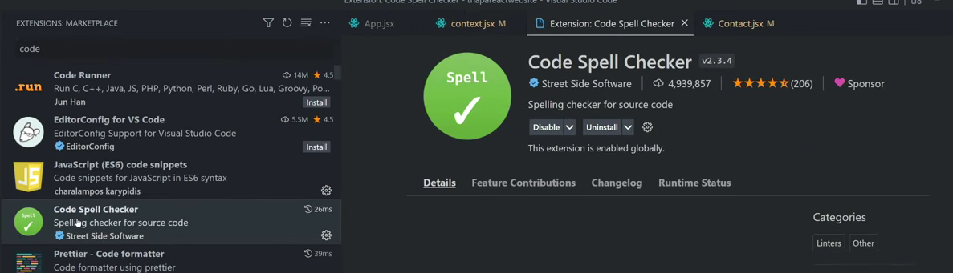

**Turbo Console log👇**

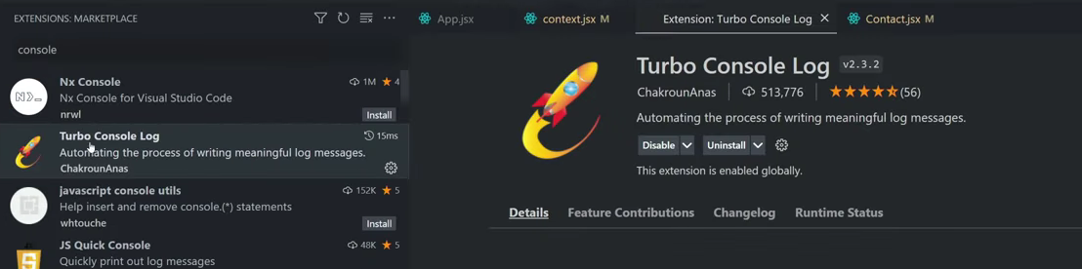

**CTRL + ALT + L**

**Swiper slider breakpoints**

Swiper Breakpoints

import life from "/images/life.jpeg";

import lilly from "/images/lilly.jpeg";

import myob from "/images/myob.jpeg";

import oldendroff from "/images/oldendroff.jpeg";

import trustly from "/images/trustly.jpeg";

import citrus from "/images/citrus.jpeg";

import grabyo from "/images/grabyo.jpeg";

import belimo from "/images/belimo.jpeg";

import { Swiper, SwiperSlide } from "swiper/react";

import "swiper/css";

import "swiper/css/autoplay";

import { Autoplay } from "swiper/modules";

import Common from "./Common";

const com = {

padding: "40px",

};

const Carousel = () => {

return (

<Swiper

spaceBetween={50}

slidesPerView={5}

autoplay={{

delay: 1000,

disableOnInteraction: false,

}}

modules={[Autoplay]}

onSlideChange={() => console.log("slide change")}

onSwiper={(swiper) => console.log(swiper)}

breakpoints={{

// when window width is >= 640px

0: {

slidesPerView: 1,

},

576: {

slidesPerView: 2,

},

*// when window width is >= 768px*

768: {

slidesPerView: 3,

},

*// when window width is >= 1024px*

1024: {

slidesPerView: 4,

},

*// when window width is >= 1280px*

1280: {

slidesPerView: 5,

},

}}

>

<SwiperSlide style={com}>

<Common imgsrc={life} />

</SwiperSlide>

<SwiperSlide style={com}>

<Common imgsrc={grabyo} />

</SwiperSlide>

<SwiperSlide style={com}>

<Common imgsrc={lilly} />

</SwiperSlide>

<SwiperSlide style={com}>

<Common imgsrc={myob} />

</SwiperSlide>

<SwiperSlide style={com}>

<Common imgsrc={belimo} />

</SwiperSlide>

<SwiperSlide style={com}>

<Common imgsrc={citrus} />

</SwiperSlide>

<SwiperSlide style={com}>

<Common imgsrc={oldendroff} />

</SwiperSlide>

<SwiperSlide style={com}>

<Common imgsrc={trustly} />

</SwiperSlide>

</Swiper>

);

};

export default Carousel;

**Class base component**

import React, { Component } from 'react';

class Counter extends Component {

constructor(*props*) {

*super*(*props*);

this.state = {

count: 0

};

}

increment = () => {

this.setState((*prevState*) => ({

count: *prevState*.count + 1

}));

};

render() {

return (

<div>

<h1>*Count*: {this.state.count}</h1>

<button onClick={this.increment}>Increment</button>

</div>

);

}

}

export default Counter;

**React Ionicons**

npm i react-ionicons

https://react-ionicons.netlify.app/

.

https://techmind.co.in/react_websites/app name/folder/imagename

Tags ko as a text print issue ayega to

ye attribute set krna

dangerouslySetInnerHTML={{ __html: props.heading }}

<h3

className="hdng fs_64 mb_60"

dangerouslySetInnerHTML={{ __html: props.heading }}

></h3>

**useId hook**

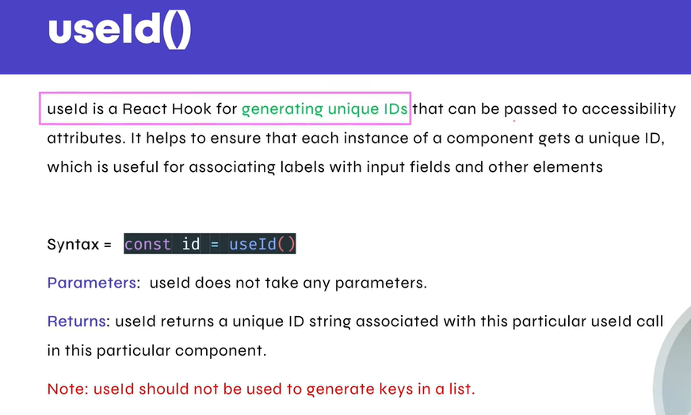

import { useId, useRef, useState } from "react";

export const FormWithUseId = () => {

const [formData, setFormData] = useState({});

const nameId = useId();

const emailId = useId();

const messageId = useId();

const name = useRef(null);

const email = useRef(null);

const message = useRef(null);

console.log(name);

const formSubmit = (*e*) => {

*e*.preventDefault();

setFormData(() => ({

name: name.current.value,

email: email.current.value,

message: message.current.value,

}));

console.log(formData);

};

return (

<section>

<div *className*="container">

<form *onSubmit*={formSubmit}>

<div *className*="input_wrap">

<input *type*="text" *name*="name" *ref*={name} *id*={nameId} />

</div>

<div *className*="input_wrap">

<input *type*="text" *name*="email" *ref*={email} *id*={emailId} />

</div>

<div *className*="input_wrap">

<textarea *name*="message" *ref*={message} *id*={messageId}></textarea>

</div>

<div *className*="submit_wrap">

<input *type*="submit" *value*="Submit" />

</div>

</form>

</div>

</section>

);

};

**Context API**

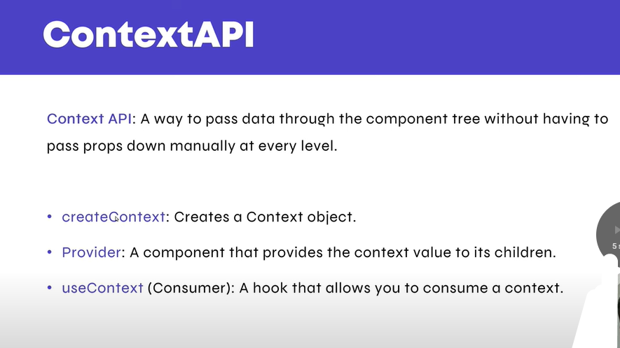

App.jsx

import ContextApi from "./ContextApi";

import "./App.css";

function App() {

return (

<>

<ContextApi />

</>

);

}

export default App;

**ContextApi.jsx**

**import { createContext } from "react";**

**import { CompA } from "./CompA";**

**const myName = createContext();**

**function ContextApi() {**

**return (**

**<div>**

**<h1>Context Api</h1>**

**<myName.Provider *value*="Mohit Verma">**

**<CompA />**

**</myName.Provider>**

**</div>**

**);**

**}**

**export default ContextApi;**

**export { myName };**

**CompA**

**import { CompB } from "./CompB";**

**export const CompA = () => {**

**return (**

**<div>**

**<h1>CompA</h1>**

**<CompB />**

**</div>**

**);**

**};**

**CompB  
import { CompC } from "./CompC";**

**export const CompB = () => {**

**return (**

**<div>**

**<h1>CompB</h1>**

**<CompC />**

**</div>**

**);**

**};**

**CompC**

**import { useContext } from "react";**

**import { myName } from "./ContextApi";**

**export const CompC = () => {**

**const name = useContext(myName);**

**return (**

**<div>**

**<h1>CompC</h1>**

**<h1>Hello, My Name is {name}</h1>**

**</div>**

**);**

**};**

**Custom Hook**

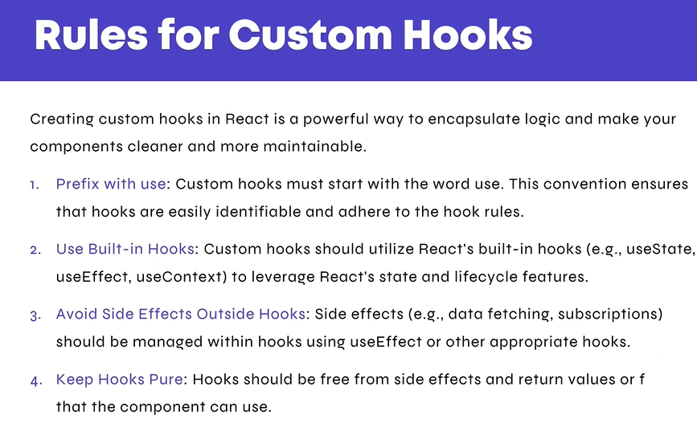

import { CompA } from "./CompA";

function ContextApi() {

return (

<div>

<h1>ContextApi</h1>

<CompA />

</div>

);

}

*//custom hook defined*

function ApiHit() {

return <h1>ApiHit function here</h1>;

}

export default ContextApi;

export { ApiHit };

**CompA**

import { CompB } from "./CompB";

import { ApiHit } from "./ContextApi";

export const CompA = () => {

const ApiHit2 = ApiHit();

return (

<div>

<h1>CompA</h1>

<CompB />

<div>{ApiHit2}</div>

</div>

);

};

**useReducer Hook**

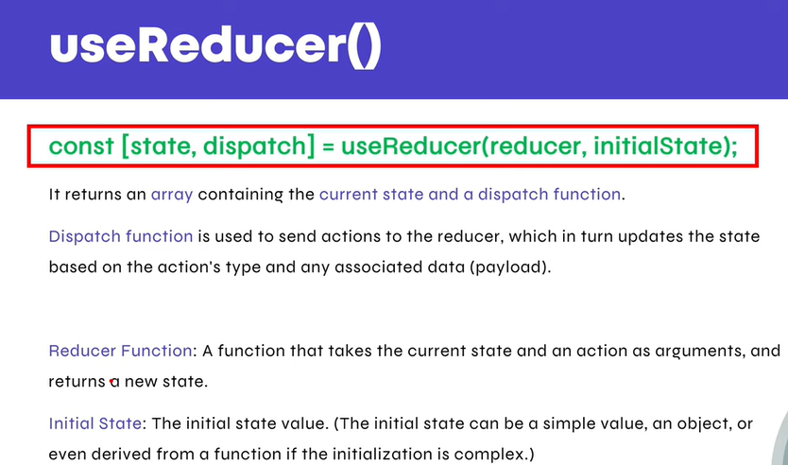

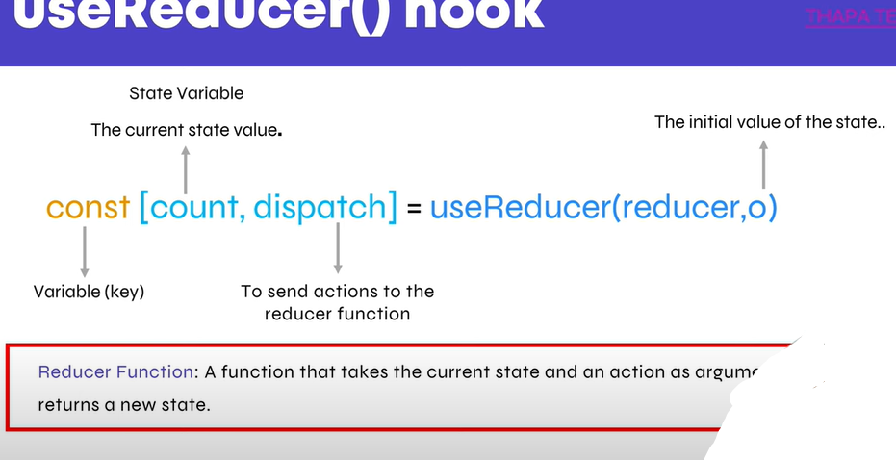

import { useReducer } from "react";

const reducer = (*state*, *action*) => {

*action*.type == "Increment" ? *state*++ : *state*--;

return *state*; *// need to return*

};

export const UseReducerComp = () => {

const [count, dispatch] = useReducer(reducer, 0);

return (

<div *className*="box">

<p>{count}</p>

<button

*onClick*={() => {

dispatch({ type: "Increment" });

}}

>

Increment

</button>

<button

*onClick*={() => {

dispatch({ type: "Decrement" });

}}

>

Decrement

</button>

</div>

);

};

**With switch case 👇**

**import { useReducer } from "react";**

**const reducer = (*state*, *action*) => {**

**switch (*action*.type) {**

**case "Increment":**

**return { ...*state*, count: *state*.count + 1 };**

**case "Decrement":**

**return { ...*state*, count: *state*.count - 1 };**

**case "Reset":**

**return { ...*state*, count: 0 };**

**default:**

**return *state*;**

**}**

**};**

**export const UseReducerComp = () => {**

**const [state, dispatch] = useReducer(reducer, { count: 0 }); *// Initial state is an object***

**return (**

**<div *className*="box">**

**<p>{state.count}</p>**

**<button**

***onClick*={() => {**

**dispatch({ type: "Increment" });**

**}}**

**>**

**Increment**

**</button>**

**<button**

***onClick*={() => {**

**dispatch({ type: "Decrement" });**

**}}**

**>**

**Decrement**

**</button>**

**<button**

***onClick*={() => {**

**dispatch({ type: "Reset" });**

**}}**

**>**

**Reset**

**</button>**

**</div>**

**);**

**};**

**With multiple object keys**

**import { useReducer } from "react";**

**export const UseReducerComp = () => {**

**const initData = {**

**count: 0,**

**incBy: 2,**

**decBy: 2,**

**};**

**const reducer = (*state*, *action*) => {**

**switch (*action*.type) {**

**case "Increment":**

**return {**

**...*state*,**

**count: *state*.count < 10 ? *state*.count + *state*.incBy : *state*.count,**

**};**

**case "Decrement":**

**return {**

**...*state*,**

**count: *state*.count > 0 ? *state*.count - *state*.decBy : *state*.count,**

**};**

**case "Reset":**

**return { ...*state*, count: 0 };**

**default:**

**return *state*;**

**}**

**};**

**const [state, dispatch] = useReducer(reducer, initData); *// Initial state is an object***

**return (**

**<div *className*="box">**

**<p>{state.count}</p>**

**<button**

***onClick*={() => {**

**dispatch({ type: "Increment" });**

**}}**

**>**

**Increment**

**</button>**

**<button**

***onClick*={() => {**

**dispatch({ type: "Decrement" });**

**}}**

**>**

**Decrement**

**</button>**

**<button**

***onClick*={() => {**

**dispatch({ type: "Reset" });**

**}}**

**>**

**Reset**

**</button>**

**</div>**

**);**

**};**

**memo Hook**

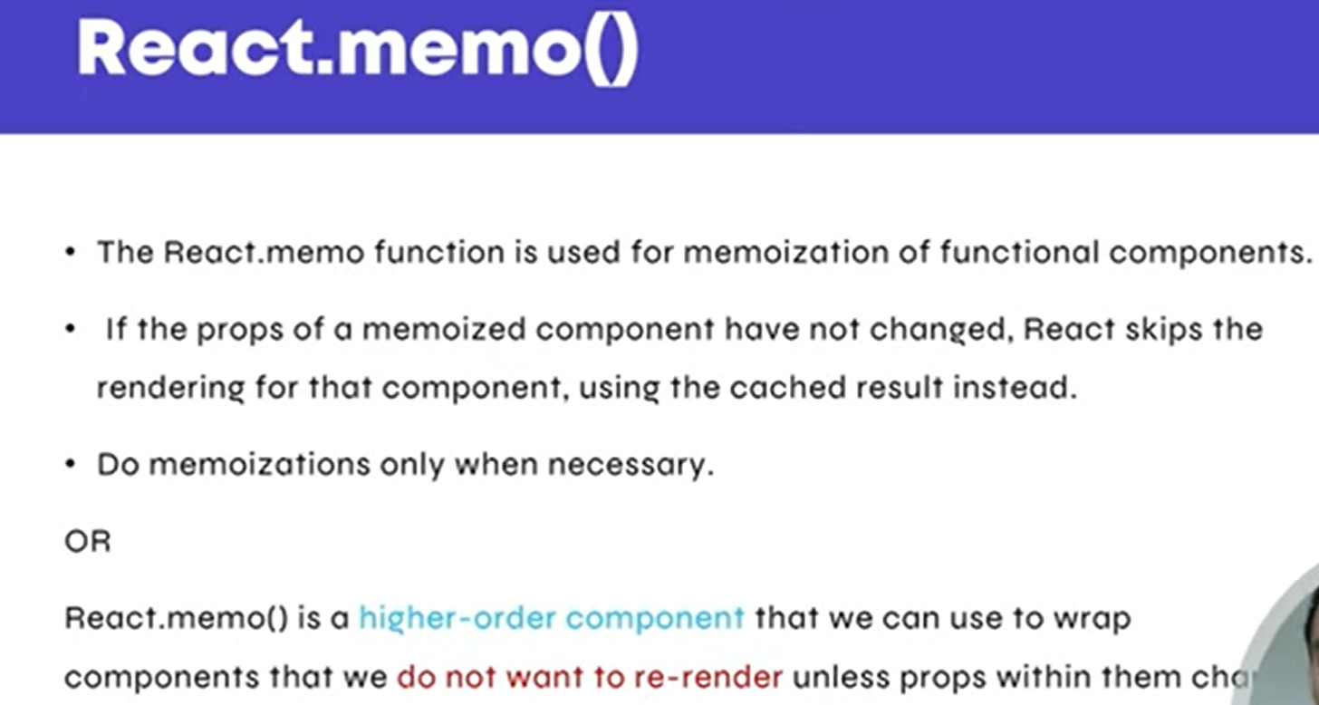

**useMemo helps avoid repeating work that doesn't need to be done again, saving time and making your app smoother.**

**import { memo, useRef } from "react";**

**const ChildCompMemo = () => {**

**const compLoad = useRef(0);**

**return <div *className*="ChildCompMemo">test{compLoad.current++}</div>;**

**};**

**export default memo(ChildCompMemo); *// (wrap component) memo used for prevent re render***

**React.memo prevents unnecessary re-renders by checking if the props have changed. It does a shallow comparison, so if an object or array is passed as a prop, even if its content is the same, the reference might change, causing a re-render.**

**useMemo helps by memoizing objects or arrays in the parent component. It ensures that the object reference remains stable unless its content actually changes, allowing**

**React.memo to effectively prevent re-renders.**

**Key points:**

* **Use React.memo to prevent re-renders when props haven’t changed.**
* **Use useMemo in the parent to ensure the reference of complex objects or arrays passed to the child remains stable.**

**If you pass an object as a prop to a child component, React's memo may not work because:**

* **Even if the object's content hasn't changed, a new reference to the object is created on each render.**
* **Since memo checks if props are the same reference (not just if values are the same), a new reference causes the child component to re-render.**

**Solution:  
Use useMemo in the parent to ensure the object reference stays the same, so memo can prevent unnecessary renders.**

**Pass object using props not working ❌ case below 👇**

**import { useMemo, useReducer } from "react";**

**import ChildCompMemo from "./ChildCompMemo";**

**export const UseReducerComp = () => {**

**const initData = {**

**count: 0,**

**incBy: 2,**

**decBy: 2,**

**};**

**const reducer = (*state*, *action*) => {**

**switch (*action*.type) {**

**case "Increment":**

**return {**

**...*state*,**

**count: *state*.count < 10 ? *state*.count + *state*.incBy : *state*.count,**

**};**

**case "Decrement":**

**return {**

**...*state*,**

**count: *state*.count > 0 ? *state*.count - *state*.decBy : *state*.count,**

**};**

**case "Reset":**

**return { ...*state*, count: 0 };**

**default:**

**return *state*;**

**}**

**};**

**const [state, dispatch] = useReducer(reducer, initData); *// Initial state is an object***

**const data = {**

**name: "mohit",**

**};**

**return (**

**<>**

**<div *className*="box">**

**<p>{state.count}</p>**

**<button**

***onClick*={() => {**

**dispatch({ type: "Increment" });**

**}}**

**>**

**Increment**

**</button>**

**<button**

***onClick*={() => {**

**dispatch({ type: "Decrement" });**

**}}**

**>**

**Decrement**

**</button>**

**<button**

***onClick*={() => {**

**dispatch({ type: "Reset" });**

**}}**

**>**

**Reset**

**</button>**

**</div>**

**<ChildCompMemo *obj*={data} /> {*/* // data is object pass as an props to child component */*}**

**</>**

**);**

**};**

**import { memo, useRef } from "react";**

**const ChildCompMemo = ({ *obj* }) => {**

**const compLoad = useRef(0);**

**return (**

**<>**

**{*obj*.name}**

**<div *className*="ChildCompMemo">test{compLoad.current++}</div>**

**</>**

**);**

**};**

**export default memo(ChildCompMemo);**

**useMemo Hook**

**To pass an object using props that works✅ with React.memo,**

**you need to use useMemo in the parent component. Here's the correct structure:👇**

**import { useMemo } from "react";**

**import ChildCompMemo from "./ChildCompMemo";**

**export const UseReducerComp = () => {**

**const data = useMemo(() => {**

**return {**

**name: "mohit",**

**};**

**}, []);**

**return (**

**<>**

**<ChildCompMemo *obj*={data} />**

**</>**

**);**

**};**

**Child Component**

**import { memo, useRef } from "react";**

**const ChildCompMemo = ({ *obj* }) => {**

**const compLoad = useRef(0);**

**return (**

**<>**

**{*obj*.name}**

**<div *className*="ChildCompMemo">test{compLoad.current++}</div>**

**</>**

**);**

**};**

**export default memo(ChildCompMemo); *//memo used for prevent re render***

**useCallback Hook**

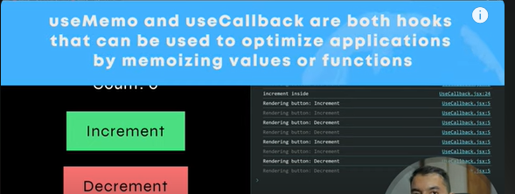

**useCallback is a React hook used to memoize functions. It ensures that a function is only recreated when its dependencies change. This can help avoid unnecessary re-creation of functions, which in turn can improve performance.**

**import { useCallback, useMemo } from "react";**

**import ChildCompMemo from "./ChildCompMemo";**

**export const UseReducerComp = () => {**

**const data = useMemo(() => {**

**return {**

**name: "mohit",**

**};**

**}, []);**

***// const printFun = () => {***

***// console.log("a");***

***// };***

**const printFun = useCallback(() => {**

**console.log("a");**

**}, []);**

**return (**

**<>**

**<ChildCompMemo *obj*={data} *onClick*={printFun} />**

**</>**

**);**

**};**

**import { memo, useRef } from "react";**

**const ChildCompMemo = ({ *obj*, *onClick* }) => {**

**const compLoad = useRef(0);**

**return (**

**<>**

**{*obj*.name}**

**<div *className*="ChildCompMemo">test{compLoad.current++}</div>**

**<button *onClick*={*onClick*}>Click</button>**

**</>**

**);**

**};**

**export default memo(ChildCompMemo); *//memo used for prevent rerender***

**React Router**

<https://www.npmjs.com/package/react-router-dom>

After installation

<https://www.freecodecamp.org/news/how-to-use-react-router-version-6/>

import { createBrowserRouter, RouterProvider } from "react-router-dom";

import Home from "./routing/Home";

import About from "./routing/About";

const router = createBrowserRouter([

{

path: "/",

element: <Home />,

},

{

path: "/about",

element: <About />,

},

]);

const App = () => {

return <RouterProvider *router*={router} />;

};

export default App;

export const Home = () => {

return <h1>Welcome to the Home Page</h1>;

};

export const About = () => {

return <h1>Welcome to the About Page</h1>;

};

**Steps 👇**

**App.jsx**

**import { createBrowserRouter, RouterProvider } from "react-router-dom";**

**import { AppLayout } from "./components/AppLayout";**

**import { Home } from "./routing/Home";**

**import { About } from "./routing/About";**

**import { Error } from "./routing/Error";**

**import "./App.css";**

**const router = createBrowserRouter([**

**{**

**path: "/",**

**element: <AppLayout />, *// For Error Page layout***

**errorElement: <Error />, *// Parent layout component***

**children: [**

**{**

**path: "/", *// Child route***

**element: <Home />,**

**},**

**{**

**path: "/about", *// Another child route***

**element: <About />,**

**},**

***// {***

***// path: "*", // Another child route***

***// element: <Error />,***

***// },***

**],**

**},**

**]);**

**const App = () => {**

**return <RouterProvider *router*={router} />;**

**};**

**export default App;**

**AppLayout .jsx**

**import { Outlet } from "react-router-dom"; *// To render child routes***

**import { Footer } from "./Footer";**

**import { Header } from "./Header";**

**export const AppLayout = () => {**

**return (**

**<div *className*="appLayout">**

**<Header /> {*/* Common Header */*}**

**<Outlet /> {*/* Renders nested child components */*}**

**<Footer /> {*/* Common Footer */*}**

**</div>**

**);**

**};**

**Header.jsx**

**import { NavLink } from "react-router-dom";**

**export const Header = () => {**

**const getCustomActiveClass = ({ *isActive* }) => {**

**return *isActive* ? "link active" : "";**

**};**

**return (**

**<header>**

**<div *className*="container">**

**<div *className*="inner">**

**<NavLink *to*="/" *className*="logo">**

**Logo**

**</NavLink>**

**<nav>**

**<ul>**

**<li>**

**<NavLink**

***to*="/"**

***className*={getCustomActiveClass} *//by default react provide active class on active item if we need to customize active or change to another active class then use this function***

**>**

**Home**

**</NavLink>**

**</li>**

**<li>**

**<NavLink**

***to*="/about"**

***className*={getCustomActiveClass} *//by default react provide active class on active item if we need to customize active or change to another active class then use this function***

**>**

**About**

**</NavLink>**

**</li>**

**<li>**

**<NavLink**

***to*="/xyz"**

***className*={getCustomActiveClass} *//by default react provide active class on active item if we need to customize active or change to another active class then use this function***

**>**

**XYZ**

**</NavLink>**

**</li>**

**</ul>**

**</nav>**

**</div>**

**</div>**

**</header>**

**);**

**};**

**Error.jsx**

**import { NavLink, useNavigate } from "react-router";**

**export const Error = () => {**

**let navigate = useNavigate();**

**const goBackHandle = () => {**

**navigate(-1);**

**};**

**return (**

**<div>**

**<h1>Welcome to the Error Page ❌</h1>**

**<NavLink *to*="/" *className*="logo">**

**Go Home**

**</NavLink>**

**<button *onClick*={goBackHandle}>Go Back</button>**

**</div>**

**);**

**};**

**API Data from router**

**Api Used**

<https://www.omdbapi.com/>

**App.jsx 👇**

import { createBrowserRouter, RouterProvider } from "react-router-dom";

import { AppLayout } from "./components/AppLayout";

import { Home } from "./routing/Home";

import { About } from "./routing/About";

import { Error } from "./routing/Error";

import { GetApiData } from "./apiFunctions/getApiData";

import "./App.css";

const router = createBrowserRouter([

{

path: "/",

element: <AppLayout />, *// For Error Page lsayout*

errorElement: <Error />, *// Parent layout component*

children: [

{

path: "/", *// Child route*

element: <Home />,

loader: GetApiData, *// API call as a loader function*

},

{

path: "/about", *// Another child route*

element: <About />,

},

*// {*

*// path: "*", // Another child route*

*// element: <Error />,*

*// },*

],

},

]);

const App = () => {

return <RouterProvider *router*={router} />;

};

export default App;

**GetApiData .jsx 👇**

**import axios from "axios";**

**export const GetApiData = async () => {**

**try {**

**const axiosInstance = axios.create({**

**baseURL: "http://www.omdbapi.com/",**

**});**

**const response = await axiosInstance.get(**

**"?i=tt3896198&apikey=ffafe907&s=titanic&page=1"**

**);**

**return response.data; *// Return the fetched data***

**} catch (error) {**

**console.error("Error fetching data:", error);**

**throw error; *// Throw the error so the router can handle it***

**}**

**};**

**Home.jsx 👇**

**import { useLoaderData } from "react-router-dom";**

**import { MovieCard } from "../MovieCard";**

**export const Home = () => {**

**const data = useLoaderData();**

**console.log(data);**

**return (**

**<div *className*="py-5">**

**<div *className*="container">**

**<h1>Welcome to the Home Page</h1>**

**<div *className*="gallery mt-5">**

**<div *className*="row g-3">**

**{data.Search.map((*movie*, *index*) => {**

**return <MovieCard *key*={*index*} *movie*={*movie*} />;**

**})}**

**</div>**

**</div>**

**</div>**

**</div>**

**);**

**};**

**MovieCard .jsx 👇**

**export const MovieCard = ({ *movie* }) => {**

**return (**

**<div *className*="col-md-3">**

**<div *className*="card">**

**{*movie*.Poster != "N/A" && (**

**<img *src*={*movie*.Poster} *className*="card-img-top" *alt*="..." />**

**)}**

**<div *className*="card-body">**

**<h5 *className*="card-title">{*movie*.Title}</h5>**

**<p>{*movie*.Type}</p>**

**<p>{*movie*.Year}</p>**

**<p>{*movie*.imdbID}</p>**

**</div>**

**</div>**

**</div>**

**);**

**};**

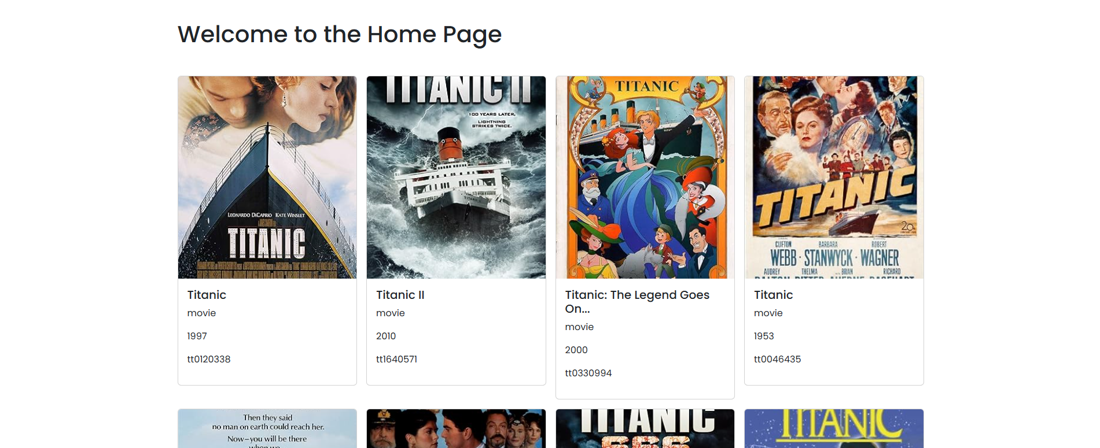

**Function useNavigation**

**Returns the current navigation, defaulting to an "idle" navigation when no navigation is in progress. You can use this to render pending UI (like a global spinner) or read FormData from a form navigation.**

**import { useNavigation } from "react-router"**

**function SomeComponent() {**

**let navigation = useNavigation();**

**navigation.state**

**navigation.formData**

**// etc.**

**}**

**Showing loader until get data from an API 👇**

**import { Outlet, useNavigation } from "react-router-dom"; *// To render child routes***

**import { Footer } from "./Footer";**

**import { Header } from "./Header";**

**export const AppLayout = () => {**

**const navigationState = useNavigation();**

**console.log(navigationState.state);**

**if (navigationState.state === "loading") return <h2>Loading...</h2>;**

**return (**

**<div *className*="appLayout">**

**<Header /> {*/* Common Header */*}**

**<Outlet /> {*/* Renders nested child components */*}**

**<Footer /> {*/* Common Footer */*}**

**</div>**

**);**

**};**

**React-router urls don't work when refreshing or writing manually**

The .htaccess file is used in Apache servers to handle URL rewriting. This solution involves configuring Apache to serve the index.html file for all requests that don’t match existing files or directories. This way, React Router will handle the routing on the client side and ensure that refreshing or entering any URL will load the correct page.

<IfModule mod_rewrite.c>

RewriteEngine On

RewriteBase /

RewriteRule ^index\.php$ - [L]

RewriteCond %{REQUEST_FILENAME} !-f

RewriteCond %{REQUEST_FILENAME} !-d

RewriteRule . /index.php [L]

</IfModule>

**Location**

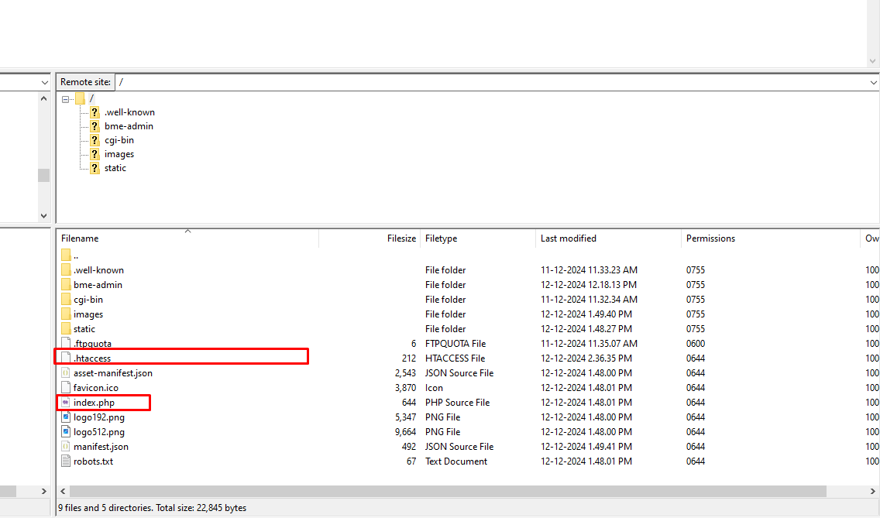

**.env file**

In a React.js project, the .env file is typically used to store environment variables. Environment variables are used to configure various aspects of your application, such as API keys, database connections, and other settings that may change between development and production environments. By keeping these values in a .env file. you can easily manage configuration for different environments and keep sensitive information secure & safe.

**Here’s how you can use a .env file in a React.js project**

Create an .env file: In the root directory of your React project, create a file named .env. You can create this file manually or by using a command-line tool.

Define environment variables: In the .env file, you can define environment variables using the KEY=VALUE syntax.

**Create environment variables 👇**

REACT_APP_API_KEY=your-api-key

REACT_APP_API_URL=<https://api.example.com>

**For VITE Project 👇**

VITE_API_KEY: YOURKEY

Get API Key from .env file and set API Key to in file

import.meta.env.VITE_API_KEY

const response = await axiosInstance.get(

*// "?i=tt3896198&apikey=ffafe907&s=titanic&page=10"*

`?i=tt3896198&apikey=${import.meta.env.VITE_API_KEY}&s=titanic&plot=full`

);

**Dynamic single post routing**

**App.jsx👇**

**import { createBrowserRouter, RouterProvider } from "react-router-dom";**

**import { AppLayout } from "./components/AppLayout";**

**import { Home } from "./routing/Home";**

**import { About } from "./routing/About";**

**import { Movies } from "./routing/Movies";**

**import { MovieSingle } from "./routing/MovieSingle";**

**import { Error } from "./routing/Error";**

**import { MoviesListingData } from "./apiFunctions/moviesListingData";**

**import { MovieSinglePostData } from "./apiFunctions/movieSinglePostData";**

**import "./App.css";**

**const router = createBrowserRouter([**

**{**

**path: "/",**

**element: <AppLayout />, *// For Error Page layout***

**errorElement: <Error />, *// Parent layout component***

**children: [**

**{**

**path: "/", *// Child route***

**element: <Home />,**

**},**

**{**

**path: "/about", *// Another child route***

**element: <About />,**

**},**

**{**

**path: "/movies", *// Another child route***

**element: <Movies />,**

**loader: MoviesListingData, *// API call as a loader function***

**},**

**{**

**path: "/movie/:ID", *// Another child route for single movie post***

**element: <MovieSingle />,**

**loader: MovieSinglePostData, *// API call as a loader function***

**},**

***// {***

***// path: "*", // Another child route***

***// element: <Error />,***

***// },***

**],**

**},**

**]);**

**const App = () => {**

**return <RouterProvider *router*={router} />;**

**};**

**export default App;**

**MoviesListingData .jsx👇**

**import axios from "axios";**

**export const MoviesListingData = async () => {**

**try {**

**const axiosInstance = axios.create({**

**baseURL: "http://www.omdbapi.com/",**

**});**

**const response = await axiosInstance.get(**

***// "?i=tt3896198&apikey=ffafe907&s=titanic&page=10"***

**`?i=tt3896198&apikey=${import.meta.env.VITE_API_KEY}&s=titanic&page=1`**

**);**

**return response.data; *// Return the fetched data***

**} catch (error) {**

**console.error("Error fetching data:", error);**

**throw error; *// Throw the error so the router can handle it***

**}**

**};**

**Movies.jsx👇**

**import { useLoaderData } from "react-router-dom";**

**import { MovieCard } from "../MovieCard";**

**export const Movies = () => {**

**const data = useLoaderData();**

**return (**

**<div *className*="py-5">**

**<div *className*="container">**

**<h1>Welcome to the Movie Page</h1>**

**<div *className*="gallery mt-5">**

**<div *className*="row g-3">**

**{data.Search.map((*movie*, *index*) => {**

**return <MovieCard *key*={*index*} *movie*={*movie*} />;**

**})}**

**</div>**

**</div>**

**</div>**

**</div>**

**);**

**};**

**MovieCard .jsx👇**

**import { NavLink } from "react-router-dom";**

**export const MovieCard = ({ *movie* }) => {**

**return (**

**<div *className*="col-md-3">**

**<div *className*="card">**

**{*movie*.Poster != "N/A" && (**

**<img *src*={*movie*.Poster} *className*="card-img-top" *alt*="..." />**

**)}**

**<div *className*="card-body">**

**<h5 *className*="card-title">{*movie*.Title}</h5>**

**<p>{*movie*.Type}</p>**

**<p>{*movie*.Year}</p>**

**<p>{*movie*.imdbID}</p>**

**<NavLink *to*={`/movie/${*movie*.imdbID}`} *className*="btn btn-primary">**

**Go somewhere**

**</NavLink>**

**</div>**

**</div>**

**</div>**

**);**

**};**

**MovieSinglePostData .jsx👇**

**import axios from "axios";**

**export const MovieSinglePostData = async ({ *params* }) => {**

**const id = *params*.ID;**

**try {**

**const axiosInstance = axios.create({**

**baseURL: "http://www.omdbapi.com/",**

**});**

**const response = await axiosInstance.get(**

***// "?i=tt3896198&apikey=ffafe907&s=titanic&page=10"***

**`?i=${id}&apikey=${import.meta.env.VITE_API_KEY}`**

**);**

**return response.data; *// Return the fetched data***

**} catch (error) {**

**console.error("Error fetching data:", error);**

**throw error; *// Throw the error so the router can handle it***

**}**

**};**

**MovieSingle .jsx👇**

**import { useParams, useLoaderData } from "react-router-dom";**

**export const MovieSingle = () => {**

**const singleMovieParam = useParams();**

**const singleMovieData = useLoaderData();**

**return (**

**<div *className*="single_movie py-5">**

**<div *className*="container">**

**<h1>Welcome to the {singleMovieParam.ID} Movie Single Page</h1>**

**<div *className*="row">**

**<div *className*="col-6 mx-auto">**

**<div *className*="card">**

**{singleMovieData.Poster != "N/A" && (**

**<img**

***src*={singleMovieData.Poster}**

***className*="card-img-top"**

***alt*="..."**

**/>**

**)}**

**<div *className*="card-body">**

**<h5 *className*="card-title">{singleMovieData.Title}</h5>**

**<p>{singleMovieData.Type}</p>**

**<p>{singleMovieData.Year}</p>**

**<p>{singleMovieData.imdbID}</p>**

**</div>**

**</div>**

**</div>**

**</div>**

**</div>**

**</div>**

**);**

**};**

**Get Contact form data using router**

**App.jsx👇**

**import { createBrowserRouter, RouterProvider } from "react-router-dom";**

**import { AppLayout } from "./components/AppLayout";**

**import { Home } from "./routing/Home";**

**import { Contact } from "./routing/Contact";**

**import { getContactData } from "./routing/Contact";**

**import { Error } from "./routing/Error";**

**import "./App.css";**

**const router = createBrowserRouter([**

**{**

**path: "/",**

**element: <AppLayout />, *// For Error Page layout***

**errorElement: <Error />, *// Parent layout component***

**children: [**

**{**

**path: "/", *// Child route***

**element: <Home />,**

**},**

**{**

**path: "/contact", *// Another child route for single movie post***

**element: <Contact />,**

**action: getContactData, *// For getting form data***

**},**

***// {***

***// path: "*", // Another child route***

***// element: <Error />,***

***// },***

**],**

**},**

**]);**

**const App = () => {**

**return <RouterProvider *router*={router} />;**

**};**

**export default App;**

**Contact.jsx👇**

**import { Form } from "react-router-dom";**

**export const getContactData = async ({ *request* }) => {**

**try {**

**const res = await *request*.formData();**

**const formDataObj = Object.fromEntries(res);**

**console.log(formDataObj);**

**} catch (error) {**

**console.log(error);**

**}**

**};**

**export const Contact = () => {**

**return (**

**<div *className*="contact_page py-5">**

**<div *className*="container">**

**<div *className*="row">**

**<div *className*="col-md-8 mx-auto">**

**<h1 *className*="mb-5">Welcome to the Contact Page</h1>**

**<div *className*="form_wrap">**

**<Form *action*="/contact" *method*="POST">**

**<div *className*="mb-3">**

**<label *className*="form-label">Name</label>**

**<input**

***type*="text"**

***className*="form-control"**

***name*="name"**

***placeholder*="John doe"**

**/>**

**</div>**

**<div *className*="mb-3">**

**<label *className*="form-label">Email address</label>**

**<input**

***type*="email"**

***className*="form-control"**

***name*="email"**

***placeholder*="name@example.com"**

**/>**

**</div>**

**<div *className*="mb-3">**

**<label *className*="form-label">Example textarea</label>**

**<textarea**

***className*="form-control"**

***name*="message"**

***rows*="3"**

**></textarea>**

**</div>**

**<div *className*="mb-3">**

**<input**

***type*="submit"**

***value*="Submit"**

***className*="btn btn-primary"**

**/>**

**</div>**

**</Form>**

**</div>**

**</div>**

**</div>**

**</div>**

**</div>**

**);**

**};**

**Axios**

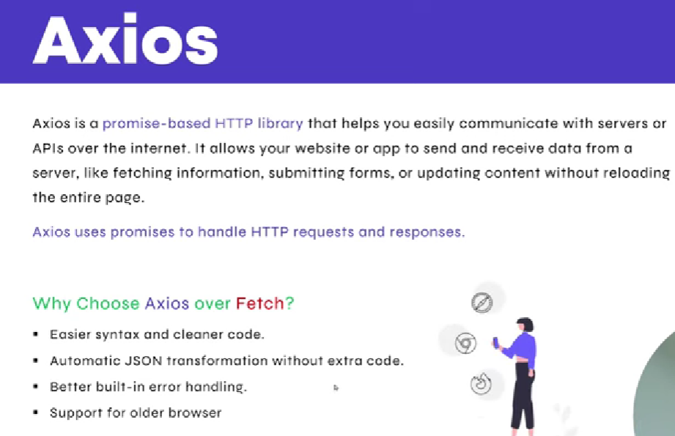

**import axios from "axios";**

**export const MoviesListingData = async () => {**

**try {**

**const API = `http://www.omdbapi.com?i=tt3896198&apikey=${import.meta.env.VITE_API_KEY}&s=titanic&page=1`;**

**const response = await axios.get(API)**

**return response.data; *// Return the fetched data***

**} catch (error) {**

**console.error("Error fetching data:", error);**

**throw error; *// Throw the error so the router can handle it***

**}**

**};**

**import axios from "axios";**

**export const MoviesListingData = async () => {**

**try {**

**const axiosInstance = axios.create({**

**baseURL: "http://www.omdbapi.com/",**

**});**

**const response = await axiosInstance.get(**

***// "?i=tt3896198&apikey=ffafe907&s=titanic&page=10"***

**`?i=tt3896198&apikey=${import.meta.env.VITE_API_KEY}&s=titanic&page=1`**

**);**

**return response.data; *// Return the fetched data***

**} catch (error) {**

**console.error("Error fetching data:", error);**

**throw error; *// Throw the error so the router can handle it***

**}**

**};**

**Build App**

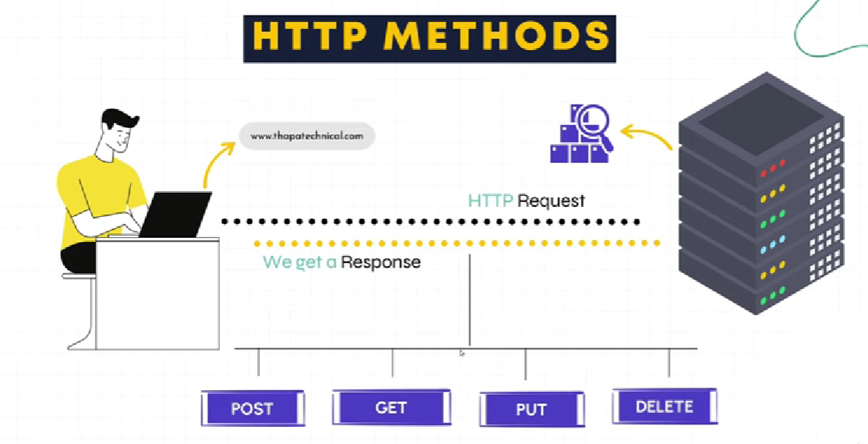

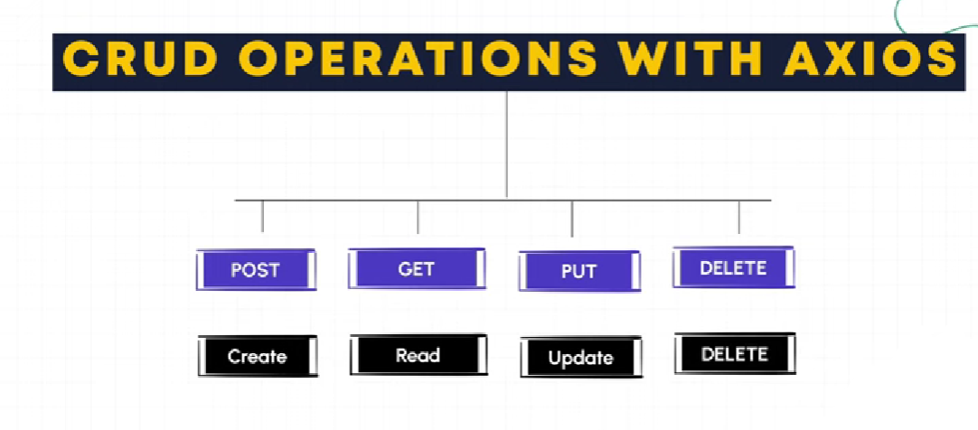

**{**

**path: "/apiCheckPage", *// Another child route for single movie post***

**element: <ApiCheckPage />,**

**},**

**import { getPostData } from "./getPostData";**

**import { useEffect } from "react";**

**export const ApiCheckPage = () => {**

**const getData = async () => {**

**const data = await getPostData();**

**console.log(data);**

**}**

**useEffect(() => {**

**getData();**

**}, [])**

**return (**

**<h1>ApiCheckPage</h1>**

**)**

**}**

**import axios from "axios"**

**const API = axios.create({**

**baseURL: "https://jsonplaceholder.typicode.com/",**

**});**

**export const getPostData = () => {**

**try {**

**const response = API.get(**

**"posts"**

**);**

**return response; *// Return the fetched data***

**} catch (error) {**

**console.error("Error fetching data:", error);**

**throw error; *// Throw the error so the router can handle it***

**};**

**}**